

**School of Computing and Engineering**

**Project Report**

**CP60046E**

Student Name: Stefan M Ahmed

Student ID: 21359035

Course: Project

Project Title: Research Paper Review Website

Supervisor Name: Chekfoung Tan

Contents

1 Introduction 3

1.1 Aim and Objectives 3

1.1.1 Aim 3

1.1.2 Objectives 3

2 Background 4

3 Conclusions 5

4 Project Plan 6

5 References 7

6 Appendix 8

6.1 Project Fair Form 8

6.2 Project Supervisor Form 8

Abstract:

People like students and researchers having to read many published research papers are likely to expect to see a record of the papers they have read. So far it is not clear that there are enough reviews of research papers. Just a few samples of reviews on different web sites is not clear enough for students and researchers to keep up to date with the material they have been reading. Especially if it is a large number of them.

A website is needed to give useful details of lots of published research materials. The website having them reviewed properly on at least several pages of the site. This allows students and researchers to keep themselves motivated to find information in one place. Find information on an item especially if they find it interesting to use or even make.

# 1. Introduction

The purpose of this project is to create a website that helps students and researchers stay up to date with useful information. Useful information for the work or research they are doing. Suppose we have students who like a certain topic, researchers trying to write an article on a topic they like or people who like to develop websites. Students and researchers may be interested in websites such as the browser that displays them. This brings on the reason to design and develop the website to help them stay up to date.

The project aim is to create a website that helps students and researchers keep to date with materials they have been reading. This could be materials such as books, articles, websites, electronic books(eBooks), magazine articles, journals. Suppose students and researchers like websites and the browser that displays them and need to research information to help them with a topic they are interested in. Because they are interested in the topic they are studying or writing an article about it. A website that tells them how useful the materials being read are a way forward.

It is interesting to develop a website. Making it is by writing code. Code in a specific language known as html. This is to make the website work and be seen on the browser by the user. HTML is like computer programming code to program a computer but just makes a website work. It works with programming code in a language known as JavaScript to make a website fully work. Plus make it attract people to use it. This is it being interactive. There are other code in other languages to make and program a website. Plus the site having a database connected to it to have data for the research material be stored in the database. There is the Zotero API that has programming code to make this happen. These are the reasons I am interested in developing the website.

The website is to be created to help students and researchers enjoy staying on track with the research materials they have been reading. There may be websites that review research papers but not completely the way that research papers are expected to be reviewed. Not completely the way to help people stay on track with what they have been reading.

## Research Background

## Aim and Objectives

### Aim

The aim of this project is to design and develop a website. A website that students and researchers can read through to keep up to date with details of materials they have been reading. Material they have been reading to do research for their coursework or exam, articles they are trying to write or any other work they are trying to produce that they need to do by researching. Have the reviews all one site that makes it easy for people to read through to know enough useful information.

### Objectives

* Research the need for students and researchers to keep a regular check of the necessary information about materials they have been reading
* Find out any reason to need to have a website that stores reviews of recently read research material together on one site
* Plan out the point of and need for having the website with use of UML diagrams
* Plan the way the website should look and be structured
* Learn the necessary topics that are to do with designing and developing the website such as online website builder to build it
* Catch up on the technical subjects to develop and design the site including html, CSS, JavaScript, JavaScript Object Notation
* Focus on ways to see if the website is worth making such as testing it
* See if the website works by getting feedback from those who may be interested in using it

Research question: Is it possible to have a website that helps students and lecturers keep on track of the progress they have made with their reading of lots of information for research purposes?

# 2. Literature Review

## Website design needs and wants

What is the best way to keep students and lecturers on track with the progress they have made with their reading of information for research purposes?

In this generation we have facts, figures and detail kept in digital form. We can go to this on a website on the computer. Depending on how these are shown for us to read we are attracted to this information.

### Education needs

An example of an interface that is simple to use to be productive is a website. Although websites are simpler form of information. University’s having websites, being important, to teach academic courses, learn, revise and answer assignment questions was looked into a model. A model that measures satisfaction, was decided to be created.

(Rezaeean, A. *et al*, 2012.) discussed a survey that was filled in by as many as 270 university students. The results were analysed using the empirical formula. The results were that more universities teaching and learning academic courses on websites keeps users such as students and researchers happy, makes them believe the methods of teaching are working and confident. Websites can just be question and answer sessions, about subjects that people definitely find interesting, such as AAB. Lots of questions as much as 3,500 have been answered and stored in the website Hone *et al*. (2011). The questions have been asked by the general public with as many as 50 researchers taking part in the session.

Researchers take part to help with and discuss the answers. Being a simple site where people just type in questions and put them on it by clicking on a button it has made lots of people visit it which is over a thousand. Hone *et al*. (2011) points out “Simply, questions are posted by visitors to the site, and one or more of our registered academic experts then provide their answers which are available for all to see and browse. The system is simple and provides direct contact between the public and scientists on subjects that are guaranteed to be of interest.” The site is used in a simple way which means the public just put questions on it for experts who have knowledge of the subject of the question to respond to the questions. The questions and answers are there on the pages for visitors to look through. Another subject by Sari *et al* (2015.) was a discussion of a solution.

A solution to improve how useful and less difficult a website is to use and the stages of learning on the website, is testing. Testing of how usable it should be to be able to improve the design and see what differences there are to the way people want and need the website to appear to them. A test was taken between 30 and 35 people who volunteers. These were students and those who work with people doing experiments in the laboratory.

To improve the design of the website the volunteers discussed in groups what are the possible ways to make a website easy and worth using. They came up with two ideas which were what it says and what is on the website, the type of language to use, images, graphics. The ideas of how the user sees what is on the site such as the size and font of the text, being able to read and understand what is written and the colors, being used, whatever they are used for. Graphics, images in different sizes should be made to look eye-catching and attractive.

### Attracting users

**(Lee, Y. & Kozar, K.A. 2012,)** A website is fun especially when planning and making it be attracted to people. It is like writing and playing music that people enjoy listening to. Lee and Kozar (2012), pointed out “composing good music is similar to designing a usable website.” Going on the web again and again depends on the type of material available on it to look at and use. What is on the web is as writing, words, phrases, names, photos, images, shapes, that way each page is laid out, sound, moving images and video (Rosen and Purinton 2004.)Deciding what is suitable to have on the web is quite important when designing it.

When we understand ways to make people use a website and be happy with what they find on it, like it is a product being sold, on the market, there is working out the answer to how to turn people who go search the internet into those who go to certain sites again and again. This like (Rosen and Purinton ,2004) said “While an understanding of marketing strategies that attract visitors to websites is beginning to emerge”, how to convert web surfers to repeat visitors is a less well-understood phenomenon. On the inter-connected network of computers websites are available to get information from offices where assessment is done. (Martinez, D et al, 2019) states they “have become the online presence of many assessment offices.”

They are able to be items that are needed to be used by assessment offices plus the place for the public find out updates of new information and learn new rules, guidelines, procedures and facts. Suppose you write text, put images, photos, videos or any type of material on a website and have got a website you could put all this on. An example of a better headline mentioned in (IntelligentHQ 2021) is “I help people increase their website traffic by creating SEO content for their blogs”. A headline that is not better is “I have an eye for writing good content and can offer content writing services.” What are the differences between the two?

The first example shows you being very clear which is help people make more people use their site plus how you would help them do so. It is not clear at all what is being said in the second one, what exactly you do and what service you can give to people. It is worth having a headline that is easy to understand when users go on the site for the first time. It is also worth saying names of brands which, or a person whose name, has appeared lots of times on the internet to attract user to your website. This is since users of websites look online for the number of times a person or a brand as appeared online.

There are information that compares brands with how many times the name of the brand is said online, to look for too. If we have a headline mentioned in (IntelligentHQ 2021) that says “We open every door in the internet to get almost every saying, of any person or any product, that is worthwhile” it is clear what is happening and what the point is in this headline.There has not been enough research done to find out the specific elements that can be used to design a useful and attractive website and even an application used on a mobile device(Garett, Renee et al. 2016). Going over and looking at elements that are there for a useful design and get a detailed list elements that are looked for most times.

These elements that appear the most to design websites the literature talks about have been finding the way through the site, use of graphics for images, how the site is laid out, use of the material i.e. content, the point of using the site, how simple the site is, and if it is easy to read and understand. It would help those who do research and are in charge of planning and laying out by coming up with ideas. According to (Garett, Renee et al. 2016) a “short list of design elements” is needed. This is for them to “operationalize best practices for facilitating and predicting user engagement.” The web has been mentioned to be like the world, of connections to many different information created by what human beings know, learn and use by the World Wide Web Consortium (Grantham, J., Grantham, E. and Powers, , 2012).

People end up working hard planning, laying out a website and making users be happy with using it by making the website wasy for users to find their way through it. On a website are search box, sitemap and indexes to let people find their way through it easily. On every page we see each page of the site to go to which are spread out on the sitemap. On the website browser are the buttons back and forward, the History and Bookmark tab, to save the page in, in the settings menu, the address bar of the website, use of colors to mark the pages that have been gone to or not to find your way through the site.

If you get lost in a page of the site you may end up clicking the back button, which is not always necessary, to find your way back. Or just type in the address beginning with http in the address bar to start all over again which is unnecessary too. The tools, on a website to navigate through it are made to let visitors go to certain pages or type in words or phrases to go to what they are looking for to use. As (Grantham, J., Grantham, E. and Powers, D., 2012,) states “website navigation tools are included in websites by developers to assist users in achieving orientation and moving in a website towards a desired target.”

There are three of the same tools of navigation that are always on the site – the sitemap, text box to search for information as text, graphics, images, photos or documents and where the name of each page is put with like a number to find it i.e. indexes. The sitemap is a map of where the pages go from one to another. It is a view of the pages like a map that makes it easy to know where to go on the site by looking at it. Probably the best and easiest way to navigate through the website as there is the pages that go the other shown together or by lines.

It may look like a list of every page from the beginning to the end in a report. According to (Grantham, Grantham, and Powers, 2012,) “the table-of-contents of a book by providing a list of the major categories of information (i.e. chapters) and their subsections.” Another subject discussed in (SUNDAY, A.A., 2021) is the technology that is worth using known as Twitter. This is where people share personal messages and facts to learn. The technology is basically a micro-blogging site that lets people post messages, comments like they do on their blog.

It is where micro sized i.e. small messages, comments are put on as much as “only 140 numbers of characters” according to (SUNDAY, A.A., 2021). Information can be passed back and forth on it using a computer or a mobile device. A person looking for a job on the internet starts communicating with the employer through the homepage. The homepage being the starting page of the website is expected to look worthwhile to people and people expect to be able to easily find their way through the site. They wouldn’t prefer it to be difficult to find their way through making them lose interest in it.

A rather simple layout and use of text on each page of the site is so far the way forward. people who are ready to apply for a job online are likely to go to the pages. **(Swartz, M. 2010)** made it clear that pages that tell them what the organisation is about and the jobs they are offering. Advertisements of jobs are expected to have at least the date telling people when the vacancy was first put on the site for the public to see and when the last date is for the application to be sent. This is the way to design a website in a simple way for people to look for information for a specific use especially for jobs. Another design is reported by (Anders, S.B., 2013.) These are the first pages including the home of the NAPLIA site.

The pages have the same menu. The same menu which takes you to the about, programs, resources, help, companies or organisations working with NAPLIA and the page to contact them. The page to go to for sources of information i.e resources has the materials to go to. The resources page has got different places to go to for accounting and those who give advice about investing. In each place there are articles that are not long. Articles that show names of pages i.e. links to go to sources of information only about NAPLIA websites.

Plus the links to websites that are outside the organisation. Long documents stored as PDF files are included in this section for users to download onto their machine and read as (Anders, S.B., 2013.) explains. Websites and databases are also interesting and useful to get data fromas mentioned by **(Yang, L., Sahlqvist, S., McMinn, A., Griffin, S.J. & Ogilvie, D. 2010)**. This is when looking through them to see the ways that make people go cycling as a sport or hobby. Ways of encouraging people to cycle have been found in reports in the databases and websites. This is to see which of the ways make people want to do more of it.(Yang, L et al, 2010)

## Reasons for online reviews

Images of “research paper review websites” on have been searched on the popular engine Google. Looking at the images have brought on ideas. It seems these reviews are examples of one or several papers.

Not of many papers put on a website allowing students and researchers to keep on track with their reading. These are not quite what they would look for to keep on track. Just examples of a few research papers being reviewed. There could be a need for a website that reviews research papers being read by researchers and students. These images are just examples of a few. Not of many on a website that reviews them. There seems to be a gap in the literature here too.

### Productive reasons

Like every organization has on the internet, the website that an educational institution has is the first item the user does different tasks on with the organization. Making the content on the website better quality depending on the information a user needs to look for. One simple aim of every website to focus on is having information for the user to look through. The type of material on a university website which a student prefers to have must be chosen.

It is worth letting children and young people such as students and researchers know what is important when planning and laying out the website. The website which has different types of media to use on it (Asadi, A. & Montazer, G.H. 2014,). (Martin-Kerry et al, 2019) describes this as checking the way it looks, whether the type of words are easy to understand. Sees if it is interesting and suitable enough and what the website is telling them keeps children, students and researchers happy with using the site. Plus make them want to use it again and again.

How to pick a hotel depending on the mentions of the quality of their service, is the topic to research which has become the centre of attention. The models that are there now show that not all the reviews and ratings of hotels are in full detail. Not all in full detail on only one website to help people choose them (Zhao, Li, Xu, 2021). There is another model to come up with of websites that make it easier for people to know to pick a hotel after reading reviews and looking at ratings. This model includes the probability of how likely it is for site users finding hotels easily by reading reviews and ratings put on the site from other websites.

Other websites that have reviews of facilities and services given by hotels and how many stars or numbers they are rated by. According to (Zhao, Li, Xu, 2021) this model helps hotels to be picked “based on Probabilistic [linguistic Term](https://www-sciencedirect-com.ezproxy.uwl.ac.uk/topics/computer-science/linguistic-terms) Set (PLTS) which integrates online ratings and reviews from multiple websites.” Having modelled the website including calculating the probability it seems that putting reviews and rating on a website from other websites is a fair amount of information that makes the information easier understand. This makes people be able to decide what to choose that is better and worth it. (Zhao, Li, Xu, 2021) makes the point “providing consumers with more objective and reliable decision-making results.”

### Health reasons

**(Dunne, S., Cummins, N.M., Hannigan, A., Shannon, B., Dunne, C. & Cullen, W. 2013,)** The amount of information online about health or for medical reasons is big for patients to look for. A lot of studies have checked the quality of this online information but not a lot of studies have checked the solutions to planning, making a website easy to use and letting websites be used especially for the public.

A tool that checks the quality of information that goes on a website, plus how easy it is to read the text on it, has come into existence. This tool is the website quality assessment (WQA) that has been used to see if information about certain medicines on a website is easy to read. See if it helps people understand what the medicine is and does (Dunne. et al, 2013,). Websites are popular for searching for academic information. It is possible that student and researchers prefer to search for details about the research materials they have been reading by going to a site that is commonly used rather than look on a search engine (De Leo, G et al. 2006.)

Many physicians have preferred to search for information that is medical like this as (De Leo, G et al., 2006) pointed out “a minority of physicians use sites dedicated to their specialized area and 4) a small percentage use medical web site portals.” A small number of students and researchers may decide to keep up to date with research papers they have been reading by looking at details that are specific to them on official sites. Official sites that have information only about the subject or topic they are doing the research on. Another online health topic is discussed by (Adams, S.A., 2011**).** There are countries that have patients who have feelings of what they do i.e. are reflexive which are to be looked into as a health issue in public or private health organisations and services.

These patients are requested more to write reviews of how they find health services provided in hospitals and by surgeries to do with their condition on websites. There are more and more websites becoming available for patients to be able to put reviews of their treatment plus see reviews put on the websites by other people with a similar condition. This shows it is worth having websites of reviews of health services especially for those who have feelings about what they do.

Responses to reviews by other patients or public lets producers of websites use these to have new products made, make the quality of health services better and change the way the health organisations and services are run **(Adams, S.A., 2011)**. Although there are similar designs of websites for writing and reading reviews on, each person using these websites believe the reviews help them choose a hotel than pick a physician (Rothenfluh, F., Germeni, E. & Schulz, P.J. 2016). There needs to be sites that review physicians, which have the planning, laying out and the information, text boxes, pictures, photos, changed to make people who use these health services know which physician they want to choose.

Which one to choose depending on what they need to be done to improve their health. “The design and content of Web-based PRWs need to be adjusted to better address the differing information needs of health consumers” according to (Rothenfluh , Germeni & Schulz, 2016). Most of the data that becomes a video is easy to use by people who watch the video on the site. This is a lot more than the data that becomes a text for people to read as they use the site. (Rothenfluh , Germeni & Schulz, 2016) point out “Whatever your website is about, be it tutorials, recipes, DIY, etc,” the headline you put on your website is the first part of the design that the user finds eye-catching. You should try to be as clear as possible, focus on what the user needs and wants and get to the point.

## Design and development ideas

### Design solutions

There is not always a lot of time to complete every job or task in this world. People try to do jobs or tasks quicker. They divide their time to do them or when they don’t have time to do a job or task they decide to do another. The point is to have a website that opens quickly if the student or researcher has not too much time to find out about an article that is useful for their assignment question or a document to write about a new subject that has been discovered. You would want them to read the pages of your site that take less time to open, or they will find another website to find out about research papers. It is about trying not to bog the reader down in too much detail of how they can stay up to date with the research papers they have been reading.

It is better to rather keep the detail simple enough than have too much of it that makes the reader lose interest in it. This includes information in paragraphs, lists, tables and even diagrams. It is suggested in (**2018, Newstex, Chatham**) “do not exaggerate anything on your website, whether it is the design or the content! Keep it short and crisp so that the visitors do not find it boring or monotonous.” You would rather keep the information about, research that has been published, as clear as possible and show ways to pages that help the students and researchers find their way through the site and not get lost. “This is a very important measure to make your website an appealing one” (**2018, Newstex, Chatham**).

A designer should aim to have on a web page shorter sentences that clearly tell the reader what is going on, paragraphs with lists and images, photos rather than just pages full of paragraphs. Tables should be put on pages for the user to look through and remember details of the subjects the paper talks about and how long the paper is. Graphics with coloured shapes and lines on each page keep the student and researcher looking through the website. It can be boring with only text. If the site is digital the designers must have work on all this. According to (**2018, Newstex, Chatham**) this is “something that the digital marketers must keep in mind while building a website.” It is useful to communicate with students and researchers when they go on the website. This to find out what they would like to know about how interesting and helpful the research papers, they have been reading, are.

How to help them find any graphs or charts showing relationships papers have with each other or any subjects or topics to do with the subject they are studying or researching on. First you would have details to contact you by sending a message to you by email on one page. There is the chat service that uses a Chatbot to reply straight away to the user of the site. Have a graphic chat as an icon on the bottom right corner of the page for the user to immediately on to start chatting in the text box. There are the graphics to link the user to social media sites and be able to subscribe to receive emails. Email about papers about topics and subjects the student and researcher often looks for. This is a sensible way of improving communication between the site designer and developer, and the student and researcher who use the site.

### Planning Ideas

A paper review website should be planned and laid out simple. One of the strategies to follow in order to get a mortgage for your home was a website that has all the details of the mortgage, how to calculate it and a calculator. This depended on what it was going to be used for. The same for the review website. Students and researchers want everything to be written simple in front of them on every page **(**Finlay, 2012**)**.

This makes it easy get to details about the papers, what to learn from them, how many references they make and any relationships they have. In the mortgage site talked by (Finlay 2012) it was the systems, policy and products. A calculator was needed to calculate how much you can afford to buy the house or flat to calculate how much mortgage you can get. How much the user can afford and mortgage he or she can get depends on the specifications he or she gives. When searching for reviews the user is likely to give specifications to find what they are looking for.

This is being “consistent with criteria” as (Finlay ,2012) said. Plus, the homepage to have enough information rather than having to click to many pages to find the information. Information is meant to be shown on pages that makes customers, researchers, students be able to choose. Choose what they need to choose to do with getting a mortgage or finding out which research paper can help them with their research task. They expect to not take long doing that with less difficulty. **(Rozic‐Hristovski et al,1999)** talks a library website can be created nowadays which would be good.

An online library that has the purpose of guiding students, people and even researchers, visiting, the university who use the sources of information and services being given by the library. The website is put together by using graphics colours, lines) to identify it as an educational institute and menus for users to find many information. Details can be looked for, to help with words used in research papers, on the site by looking under the subjects the detail is divided into. Dividing the details like this helps people, researchers using the university library and students browse the site and find it is worth looking at. There is a lot more other information that is not in the pages for the subjects to find. A search engine is put on the website to let them find the other detail.

To see how well the website is doing by having enough people using it the records of each use of the site in the web server were looked at and checked. The records are taken out of a big database which has a lot of columns of data stored in it which is known as a data warehouse. It seems there are ways, which have been mentioned, to develop the website later. The medical library (Rozic‐Hristovski et al, 1999) studied about being made, was seen how well it was doing like this.

### Development Solutions

There have been a lot of improvements to the World Wide Web over time. Over thousands of websites pages have been created and put on the internet (Bouvier, D.J., 1995). All the information, pictures, photos, images, text, tables and other material on the web page for finding out about research papers on piano and guitar chords, Pythagoras Theorem, Binary data, Memory chips is about the language written to create this on the pages known as HTML. A study was done by (Cutler, M. et al,1997) on documents written in HTML markup language are made of the tags that have the lines of HTML code.

So far it is easy to see how the text appears on a web page in an HTML document. The way information is shown on a document can be told by the lines, written in this markup language, using these elements. Words or phrases that are written as titles, headings in different sizes, italics, bold or have underscores between the words are first wanted and needed. Wanted and needed to be read by the researcher or student before reading the rest of the information. Text in bold, italics or underscored are being emphasized. Groupings Of The Tags: Tags in HTML that make the beginning of information draw the student and researcher to it are put in groups by (Cutler, M. et al,1997).

The groups are for tags that keep the text normal, put the title at the top, the first two big headings and the third big heading to the smallest - 3 to 6. Also anchor and strong. Strong tags make the text stand out and anchor is for attributes that make links to other places of detail. The normal text group is for text that is not made into headings, titles by HTML. It is more practical to have groups that have the HTML tags rather than a group for one type of tag. It makes the ordered list of groups shorter to look through for the elements. (Cutler et al,1997) then put the tags into the groups Title, H1 with H2 and H3 to H6.

In the groups are the tags making the title, headings 1 and 2 and headings 3,4,5 and 6. The title of a document is more separate at the top of the page and says in one or a few words what the document is telling the reader. It should be in its own group rather than in a group of two or more different HTML tags.

The two biggest headings 1 and 2 tell the student and researcher the information that is most useful than what is on the rest of the page. Where the reader begins on the paper review website when they start reading the page is one example. The page that tells them how to use the website. These headings are put in group 2. The smaller headings made by tags 3 to 6 give details to the reader.

Details such as what options they could choose or type in when doing an advanced search of reviews of research papers. The details are less useful than those in the first two headings but is where the reader looks to find what they are looking for. These should be put in the third group.

There is one group to have text that is not shown as normal but gets the attention of the reader by being written in lists and emphasized - put in bold, having a line under it, slanted i.e. italics, having an underscore in the words. This is the Strong group. The tags for making these types of text go there. This was a way of looking into details that begin with text being made to appear like this. These details of text are the most useful points in the document.

The student or researcher will read these first according to the author. The useful points could be a list of sections of an article, journal Article, book or website. The abstract, introduction, methodology, conclusion, references, citations to read to see how relevant the paper is. How relevant it is to the researcher or students subject or topic especially if text is emphasized.

The anchor group is for the attributes that go in the anchor tag to make links in the document to other websites, documents, pages. Academic search engines Google Scholar, and Summon 2.0 at the University of West London library are good examples. The users go there to look for and read the research, review papers or position materials they are reading the reviews of, for their coursework or research question.

It is worth putting this anchor group in the ordered list since this elements attributes take the student and researcher to extra information about what the document says. Students and researchers will go to pages, documents of extra detail to see if it will help them with answering the assignment or research questions.

Links to the journal article, newspaper article, website, electronic book, position material are usually on the document as well as websites these materials of research are found on. When looking for specific topics of research and the papers, they are written in, it is good to make sure links in the anchor tag go to the right document. This whether it is the document on the website or the links from the website.

Searching For Information: A system for searching is usually a search engine. The search engine on the research paper review website is a In HTML terms program that works by the user typing in terms in the text box, clicking the Search button. The controls on the Search page, like a form, are made by HTML code. The terms are entered and passed to the database which gives the results, to the user, as a list of links written in HTML.

When searching for specific details of a paper they have been reading they could type in Boolean operators AND, OR, NOT. They could also put one or a few terms in speech marks separated by commas. The user can also choose to have details of research only in tables shown to them and a paper that reviews another paper or is an argument i.e. a position material. People go on the paper review system to look for information by browsing and searching. They start by browsing. Systems that information are browsed on go from one page to the next.

(Cutler et al,1997) mentions they “organize information in the WWW into category hierarchies. Examples of this type of systems are Yahoo [Yaho96] and Magellan [Mage97].” They then search. The student or researcher types in the terms to find reviews of a research material. They try to find a review using Boolean or type in more terms in textboxes. They also choose or not choose drop down menu options. The engine gets from the database the list of links to the details of research papers. Research papers, papers reviewing another paper, position materials depending on what the user has entered to search. The HTML code written to lay out the text on a web document has lines in the code that can be looked at that make words in the text stand out (Garcia-Plaza et al, 2017).

This could be the page that tells the reader how to look for relationships between papers of research. (Garcia-Plaza et al, 2017) came up with a “fuzzy term weighing approach that makes the most of the HTML structure for document clustering.” They describe the “hypothesis that a good representation can take advantage of how humans skim through documents to extract the most representative words.” How quickly people go through documents to find useful words that to depends how many of the words are made to be written by this markup language in the styles.

Documents of descriptions about subjects and topics like Physics, Digital electronics, Telecommunications, Trigonometry, Bar charts, Calculators, Telephone networks, Melodies, Quavers, D major, Rectangles, Binary addition and subtraction, Processors, RAM, that people are likely to find interesting do their research of is a good example. Html elements such as heading tags (h1 to h6) make writing in the document stand out and get the reader’s attention to what is written. This could be details of each type of paper to that is reviewed – a research, paper reviewing a paper, position material. People who write code in html language to write the web pages put HTML tags in the code to write text in italics, bold, as headings, in bigger size of font or just titles to the page give. The text written like this to grab the attention of the reader to it. (Garcia-Plaza et al, 2017) points this out is to “convey the most important message of a web page through page elements that attract the readers' attention.”

### Using Tables

A table is a rather simple, interesting way to tell people information. Table is a very common presentation scheme. It is worthwhile knowing what the cell, the data goes in, in the table is for when noticing in HTML the lines written to make the table. Plus how to use the table for what it is going to be used for. In HTML you can choose to put a caption about the table you are creating (Chen, H.H. et al, 2000).

You then write the tags to make the rows of the table. At least one or a few cells are a row. These are the headings and then the data under them. Cells can be merged across rows and columns. There are tags being used for: The wrapper to lay out the whole table in a style that makes the student and researcher start looking at it. The row of the table, data to go in each cell of the table. Headings of each column in the first row and the caption such as a phrase or words to choose to put such as “Papers about similar subjects”.

The columns are attributes. The cell is there to have attributes in it. It is either those or any data such as a word or a number that goes in the table, basically a value. An attribute can be shown by joining several cells together i.e. concatenate them. An example is “Subjects - How easy to understand - No.of words to learn” shows about the paper any subjects to do with it, how easy to understand it and the number of words it has to learn. The details of a research paper that are to do with each other are noticed in the columns or rows.

Noticed by the student or researcher starting to look for the relation in the rows or columns as (Chen, H.H. et al, 2000) points out “relationships may be read in column wise or in row wise depending on the interpretation.” An example of details that are to do with each other in two rows is “No. of pages: 8”. The “Date published” of the paper is the relation in the columns a researcher or student wants to quickly check. If the designer wants to draw the users attention to the tables on the paper review website they could have the table covered by a wrapper.

Have a style of the cover of the table. (Chen, H.H. et al, 2000) says the “wrapper (<table> …</table>) is a useful cue for table recognition.” This wrapping works by putting the tags that make the table with lines of code under the wrapper. Having wrapper elements, in the HTML file, with the tags for the table between them means a table is sometimes not on the web page. Developers use table tags to make a form or menu. They could do so to let students or researchers type in filters, choose options from drop down combo boxes or tick boxes to try searching for the exact information about the research they have just read.

It also worth saying the ColSpan and RowSpan attributes are used in the table row and data tags. Col]Span IS used to join two or more cells, into one, to be in two or more columns. RowSpan is used for joining two or more cells into one that go in two or more rows. The cells are joined by giving the number of columns to be joined under or number of rows to be joined in. An example could be the ColSpan of the cell, that has “Chords”, being given equal to four. This makes the cell go in four columns. The RowSpan of cell, having “Fact”, being given two.

This makes the cell go in two rows. Designers can use these attributes as much as they like to make the table highlight information. It takes time and is not immediately easy for the student and researcher to see what the table is telling them about the research. This compared to a normal table. (Chen, H.H. et al, 2000) states “they make automatic table interpretation more challengeable.” However, data in tables on the Web, created by HTML lines of code, is organised but the student and researcher does not know immediately how the table is organised. Plus where to find the data they are looking for (Embley et al, 2005.).

This means the user cannot search for specific data straight away such as new words used in research papers to learn, how well the research they have read is close to their subject or if the research is a fact or opinion. If students and researchers want they could try to look into how tables are made to store data in the columns and rows by HTML. Do this to come to the tables that have the details they are looking for. Try to know exactly how a table has information stored in it lets tables, that are wanted or needed, be found in an area of the web page.

It lets you notice the attributes as columns are attributes and data as numbers, text, Boolean values, basically any value. You can put the attributes and data, being any value, together as a pair put them to make a summary out of the table. The summary could be a record. Doing a practical test on web based tables by going through their HTML lines of code helps you see that you can find and go to data that is wanted and needed in the tables that you don’t know the organisation of.

Plus see how the data is made to be in that table as well as the style that covers the table known as a wrapper. You can look for specific data when you know exactly the specific information you are trying to get but do not know how they are organised yet. Testing on web-based tables being done:Suppose the researcher comes across a table that has only one column of references by a paper used for research on shapes.

This column of references is likely to be a list. It does not have a table tag making it a table but a li tag that indicates it is a list. An ordered list of the references rather than a table of them. If the table comparing similar papers has around 30 rows and only as much as 10 or 15 rows are on one page.

You could practise making a “Show More rows” button let you see the rest of the rows in the system. Useful in the research paper review website for users to look for as much detail in the rows to help them compare similar papers. For the page comparing similar research papers there can be one line of code to put detail on top of the table and one to put data in the table and detail in the footer under the table. These lines are in the table tag.

There can be two pieces of detail in rows that do not go in the table. These last two lines of the table are not actually part of the table. These are the link to the Sitemap and Homepage, email address to contact the owner of the site, confirmation that the site has been published and the year it was last updated. Made by the tags being put under the table tag.

Useful when the user comes across these details when trying to find papers to compare or that are similar. The practical test (et al,) talked about had “Tables spanning multiple pages*.* We obtain the page in [Fig. 3](https://www-sciencedirect-com.ezproxy.uwl.ac.uk/science/article/pii/S0169023X04001557?via%3Dihub#fig3) by clicking on Honda Accord EX in the table in [Fig. 2](https://www-sciencedirect-com.ezproxy.uwl.ac.uk/science/article/pii/S0169023X04001557?via%3Dihub#fig2). Clicking on all makes and models gives us similar pages. Each page has a column of attribute–value pairs that starts with Price and ends with VIN. The collection of these columns from each page constitutes a large table whose attributes are all the same, Price … VIN, and whose values are the value columns from each linked page.”

### Styling Pages

CSS is a language that is used in many places on the web that sets the way content on pages look and are laid out. It stands for Cascading Style Sheet which is the sheet the code is written. Hence why this is the name of the. The language puts the material on web pages in many different styles.

It is used to style the content on a web page. Where text is put, font and size of the text, colour of the background, how big the borders are and their colour, where images, photos and borders are positioned. Also, the color, font and size of paragraphs, headings and many other content **(Mesbah, A. & Mirshokraie, S. 2012)**. All the code on the end that receives i.e. the client, with the lines of CSS code that has not been run, should be let by the browser to open an application running on the web.

If the files have big code, the size of the code is big on the computers, and devices that are connected. The size is also big on the server and browser. The web browser is the program that sends and receives a lot of data to and from the CPU while running. They work hard. Suppose we have lines written in CSS language to style the web page. These lines rule the way the page looks. The lines are made of the parts that select and declare. The first rule could be #similar that sets how the border of the table looks and to be as wide as 1px and colour being blue mixed with some red and green. The amount of blue in it is 135, 16 of it red and 19 green. This is written as rgb (16, 19, 134). The text being made to stand out by being bold in the table headings, slanted i.e. in italics in the data cells.

The style of and how big is the text, which is the font size of 30px. Each part that selects is the id or class. Style the table that compares similar research papers. A selector makes one or several elements be laid out on the page in a size, colour, dotted, dashed border or padded away from edges on the paper review website pages. These are headings in a given font, table headings, table data going in the cell or the border of the table on. Used on the pages of details about the research method used for playing notes in music and finding missing lengths of rectangles.

The code that declares is written in curly brackets. It has properties that style the elements, with their value, on the paper review system pages including Latest Reviews and Relationships. The properties to declare like the background colour of each page on the paper review website having the value #FFF000. This is yellow. Another property (**Mesbah, A. & Mirshokraie, S. 2012**) explains is text-decoration. This makes the text eye catching to the reader. It has the value putting a line under the text. The colour of the text and what makes it eye catching are basically properties to begin with.

It is good to have this on the page that tells the reader the methods of research used for example to write an article on sine waves. The details of the Sine waves article have the property font which has the value Verdana. Verdana is a family of fonts that give the text the look details to. Selectors that are elements rather than class or ID take an element, that has attributes or not, to style.

A good example is h2{colour: brown; float left;} takes a h2 element to make the second big heading brown and float the heading on the left, of the page that tells you about each type of paper. The IDs, which are called in lines of code to add a style to the element, start with a hash. Hash is the prefix. Classes with their code lines to style the page begin with the dot when they are first put. Dot is the prefix.

ID and class selectors can be stated to give a style to a single element. The element is given the style wherever it is on the pages by putting it with the dot prefix and the class. Elements that have the attribute class being equal to take are chosen by the selector such as ul.take { padding-left: 4px}. This takes ul elements and pads the list wherever the list is used on the pages giving details of a page from a book about Sine, Cosine and Tan calculations. The list is padded 4 pixels from the left of the edge of the page.

The ul not being put or any other element with the “dot” and “take” lets the take give a style to any element on the research paper review website that has the class as the attribute (**Mesbah, A. & Mirshokraie, S. 2012)**. The three coding languages to design and make the paper review website are written in a separate file. Each file like a sheet of the lines of code in each language is according to Keith and Scripting (2005, p. 5) “Structure, Presentation, Behavior” which are “readable by web browsers.” The structuring side relies on the hyper-text mark up language HTML being written to put headings, paragraphs, lists, images, photos, tables, captions about interesting topics of research on each page.

The brackets used to show greater than or equal to have words. These are the tags of elements that put content on each page. Content such as a paragraph saying “This paper is a journal article on drawing a quadratic graph. It has references to papers on the equations of a straight line and articles on straight line graphs on a calculator. The method of research used is helpful enough for the subject or topic you are studying.” The paragraph tag <p> only lets you see these sentences. It does not let you see how the sentences look, are coloured, laid out.

The presentation side is done in the cascading style sheet. The lines of code let you see how the text, images, photos, tables, captions look.

What colour, size, style, borders are being used on the content telling the user about research papers on spreadsheet formulas, SQL database programming on each page. Cascading style sheet CSS is the language used to style the content. According to Keith and Scripting (2005, p. 5) it lets you see the colors and style of sentences in a paragraph as well as what the sentences are telling you. Lines of code in CSS let you see paragraph of sentences about spreadsheet formulas, SQL database programming research papers.

These can be coloured black, red, brown and styled in Helvetica font. Letting Students and researchers see how information, about research on plotting graphs on calculators, looks on the pages takes enough time. A fair time by doing it with JavaScript code. It is better of doing this in CSS. When it comes to changing details that make an element look better on the web page by a given time JavaScript is the way forward.

JavaScript has functions you can use to change details that give the look of an element in a given time. If you wan to add some effects on the border, around a graphic on a page i.e. animation you need the function to change the code of details of the element after a while.Where an element goes when seeing it on the browser tells you how the page is presented as Keith and Scripting (2005, p. 5) points out. CSS is the best language to write code telling the student and researcher this on the page.

This is all about the position. This example of basic CSS code making the ol element put an ordered list on a part the page comfortable is: “ol {position: relative; top: 25px; left: 75px;}”. These lines of code will put the ordered list of words used when doing research of Music: 1. crotchets, 2. quavers, 3. arpeggios, 4. C minor, in the position. This is how far it is from the top and left of the edge of the browser measured in pixels. 25 pixels from the top and 75 pixels from left.

The basic values that can be used in the position property are “static”, “fixed”, “relative”, and “absolute”. According to Keith and Scripting (2005, p. 5) elements like this ordered list are put in position by having the value first set to static “static”. “Static” is the lists appear in the order they are made to appear by the language that marks up the list. Making the list of music words, students are interested in, being positioned relative on the page is better.

Keith and Scripting (2005, p. 5) explains it is like static but lets the property known as float be used. The float used make the list of music words just float on the left or right of the page that reviews. The words do not appear in the order given by the HTML mark up, to be positioned, if the float property is used to float them on the left or right. Using CSS3 and HTML5 to plan and layout the pages of the website is explained more by **(Yadav, P. and Barwal, P.N., 2014)**. In CSS code classes are put and then called in one or more places in code.

The classes are there to save too many lines from being written and run to style the web pages in the project. Example: Suppose a researcher goes on the paper review website that has a cover. This is the wrapper that is made in the CSS to attract them to the site. It is covered around what is on each web page. It is 960 pixels wide and the researcher has opened the page fully on the browser on a 1920 pixel wide screen to look at new words. New words to learn, from a paper, in a table.

The pages that tell the student and researcher how to find out how research papers help them with their coursework or topic they are researching and pages of tables of sections of an article being reviewed are meant to fit the browser window. If there is a cover around what is on each page, the designer has to think about it how wide it is. It should be wide enough to fit the window. That is not too wide or too narrow. You can know by how much you could try to make the site be laid out to make it interesting on different screen sizes, computers and devices.

This is in percentage by dividing width of the wrapper by the width of the screen. So 960/1920 = 0.5, to get it in percent is 0.5 x 100 = 50%. There can be areas to lay out the page in. Done by putting classes in the CSS code to style each area. Lines of code to style them in different lengths, how wide they will be by measured in percentage. You can write more lines to make another area or more small areas be laid out in each area. Do all this to fit what is on each page on the browser window depending on the size of the window and the screen.

As (**Yadav, P. and Barwal, P.N., 2014**) mention “defining different CSS classes defining length, width, etc in percentage, which can also be used for further division of the sections into sub-sections to fit the content as per required.” We can put the first class in the CSS to set how wide the content in the body of the page is. Set for the researcher to be able to see clearly where to start finding about the research papers he or she has been reading. This class has the lines referring to the body tag. This styles the entire content on the page. Then the second class that makes the page be styled into two halves.

There are classes to put in different parts of the code which are called to make the page look the way the user would like it to look. This depending on how the user would like to see how the paper review website looks. Classes are used to make web pages look better by: being relied on for setting different sizes for each page are used in the style sheets. Also, by being used in many parts of the code. **Yadav, P. and Barwal, P.N.,( 2014)** state “the whole class will be the total width of the body tag, defined in your CSS and the one-half class will divide the page into 2 halves horizontally. Similarly, as per our requirement different class are designed in CSS which can be used at different point in the code.”

### Programming Ideas

You only need a text editor and a browser to write Javascript to run web pages. Lines of code written in JavaScript work with lines written in the HTML or XHTML language by running the file that has the HTML OR XHTML lines. This is by writing the lines to call the JavaScript source file near the top in the HTML file (Keith and Scripting (2005, p. 5).

Or bits of the JavaScript code itself can be written above the beginnings of parts of HTML or XHTML code to make a student or researcher fill in their criteria to search for details of a research article. You can place the JavaScript between the body tags of the html or head. Basically the script tag is used for is putting the lines of JavaScript code in the tags or a link to the file that has the script of lines. The file is saved in the programming language with .js extension. The lines of code program each research paper review web page.

The page is made to look lively i.e. interactive to the user. Lively with moving shapes, colours, text and controls, text boxes, buttons to use and fill in. These on the pages that users can search for details of research papers on business packaging or C++ programming language. Or where there are tables showing which light circuit research papers review another light circuit paper. The link to the JavaScript file is within the script tags in the body or head. It has the source attribute src pointing to the name of the script file. The name could be “paperreviewsite.js”, “<script src = paperreviewsite.js> </script>” in this case. Putting the lines of code in the script tags with the HTML code is worth it if there is enough or not too many lines to write.

Lines that have the dot notation, equals, if statements, methods, functions, variables, names starting in lower case are used there to make the pages better that the student and researcher enjoys looking at. If there are too many lines of code to write in the HTML file to program the pages, where the user finds out about written research of interesting topics, it is better to write them in a separate script file (Keith, J. and Scripting, D.O.M., 2005). The browsers used today like Firefox, Google Chrome, and Safari are improving their running of files of code written in HTML5, CSS3, and JavaScript to load interesting web pages. (Bakhtiari, M. 2012) states “The HTML5, CSS, and JavaScript programming languages were used to develop several applications for Quality Assurance in radiation therapy.”

In HTML5 we have the canvas tag. Lines were written under this tag to make the images be shown in the right size with labels, captions, borders and from their right location. The element used in HTML5 to make images with JavaScript and put them on the web page is Canvas. JavaScript code was written and run to put effects on the image, make its colours move or the border colours move around it or make it look alive. Programs like this to put data as reviews of research papers are worth having since the programs put the right amount of data on the page quickly with the results. JavaScript can put data on pages like this because it is a more basic language to do programming in i.e. low-level.

Done by its lines written in a text editor like HTML is. Only needs the editor like Notepad++ to assemble it on. Doesn’t need to be compiled on a programming software like Eclipse or Netbeans. All the HTML does is link the script file to make images be drawn on web pages like that. It also takes up less file space (kilobytes KBs less than Mega MB) when the scripts are saved in the language. It is smaller than files used on programming software to compile. JavaScript is different to higher level programming like Matlab. Its running of programs on the website is more basic. Plus it does tasks on computers, which are the client, that ask for a service rather than on web servers.

Code is written and run in HTML5 and JavaScript to make applications be used when connected to the internet or not and when they are. Many browsers to search the web on allow the applications to be run on them. HTML5 and JavaScript can be used to develop useful applications that can be run online or offline on different modern web-browsers including Firefox. (Bakhtiari, M. 2012) states “one of the modern web-browsers are mostly open source (such as Firefox).” A study by Jacobs et al (1996) is CoWeb. This is a way of helping two users connected to the internet work on the same document. It lets several people do tasks together on a document, written in HTML, away from each other.

It is not used on the Research paper review website at the moment but gives an idea of how it could be used by students or researchers sharing ideas with each other about the subjects they are working on. The lines of the elements in the HTML document are turned by CoWeb into Java programs to make the document be edited by the users while they are connected. It allows them to pass the document back and forth to each other through CoWeb. An example being typing text into textboxes, ticking checkboxes, choosing options from drop down boxes to find and learn the method or researching used in a newspaper or journal article.

Done by users working together on the same topic or project. An image on page about an article, electronic book, website page can be marked. Marked by pointers and extendable rectangles to show useful points on the image. There is also a chat service for students and researchers to quickly send messages to each other.

Messages about what to add to the document, remove, fill in, make notes off and discuss. The programming language that runs CoWeb is Java. It relies on Java to let browsers run the programs written in the programming language. These programmes are called applets. Applets are used to make a page written IN HTML interesting the same way images are used on a page. CoWeb just puts applets in the HTML document and runs them instead of the HTML elements.

Having CoWeb was about trying to see if the Java programs can make the same document be edited by several students or researchers at the same time. Removing and replacing code in HTML documents is on the back end from the users working on the same document - they don’t see any the code being replaced and removed. They continue editing the document as it is being programmed to let them edit it together in new ways. The CoWeb has documents that it begins with.

It begins with these that are already made to work online rather than needing to make any program work by writing code and running it in the Java programming language. The server starts sending and receiving data by the computer if the computer can work with code written in Java programming language. The lines in the HTML document are edited by the server. This is by taking the lines apart to seeing what each part does such as equal signs, dot notations being used and how it is written i.e., parsing.

They are parsed for words used in HTML forms and the search page of the review website such as Method = GET, Method = POST, input type = checkbox, button type = button. These now become programs being run by syntax written in the CoWeb language. The lines have syntax beginning with “Co” that indicates the code is being run on this system.

Like the CSS ID and class selectors being used as attributes of elements to style the elements the HTML lines of code are replaced by the words including APP and ID. A good example is BUTTON ID that takes over BUTTON TYPE = “BUTTON”.

(Jacobs et al 1996) points out “keywords like INPUT TYPE=text are replaced by applets like APP Class = CoText” since students and researchers working together mostly gill in textboxes to search for reviews. While transmitting the document still looks the same but with new lines that have methods. Methods that make groups of students or researchers change the document together when they are online. notherA form of JavaScript that can be written to make programs allow computers, devices that are connected to each other send and receive data is Node.js (Tilkov & Vinoski, 2010).

Node.js is a type of JavaScript code that makes the server respond to requests coming into it from the client. It is good to have this to make the website run faster soon if not the moment. Data between devices on the network is made to be Communication of faster and done a lot more than the simple programming languages.

Bigger sizes of data packets are also used by Node.js. It is worth having the paper review website load its pages faster when connected to the internet for the student and researchers. The server having copies of the html files of the research paper review website pages stored on its hard disk drive that it sends over the network.

(Tilkov & Vinoski, 2010) explain it follows the http format to do the sending. A student clicking on a button or pressing an Enter key, basically an event causes data to be input and then sent from them as the client. The event then causes data to be output as a reply to the client. When the server gets asked by the student client for Latest reviews, Subjects, Topics page to be given on their screen it looks for the live copy of the files that make the page.

The live copy is looked for by checking the URI that has been received has the same name of the Latest reviews html file In the live copy. If the URI has the same name, the server goes through what is in the html in the live copy before sending it as output to the client. Sends by following the HTTP format. Following this format that lets the HTML be transmitted as the page.

The next HTTP server (Tilkov & Vinoski, 2010) explains is the same but sends the web pages differently. It reads portions of the Subjects, Topics, Types Of Papers html pages before outputting it to the client. It basically does the same which is get the URI it has received from the client that followed the HTTP transmission format. Then it checks the name.

Checks the name of the html file is the same as the one in the URI. If the name of the html is there the server goes through portions of it stored in the hard disk drive. It does so, instead of reading the whole file, before sending it to the client by following the HTTP format. This format it follows is for each portion of the file to transmit it.

## Storing research data

Zotero is a tool on the browser that is used to gather and store references, citations, sources of research. It saves all these as students, researchers look on the browser at materials of research on Music, Rectangles, Processors, Handling data. It is useful for them to keep a record of references of these topics by the tool. Being operated on the browser means it can be available as an application on the desktop (Pearlman, A., 2019).

The student, researcher has the web browser and the Zotero tool on the desktop as shortcuts. There are tasks the tool lets you do on the browser as well choose how to mark pages of research topics. This is known as bookmarking. Users can have a bookmark of the page in the HTML file the page was developed in. An example is reading an article about CSS making borders and colours look attractive on a web page.

The student, researcher reading the article in a PDF file when online can save it for help with their assignment or research question. Save it by one click of a small image i.e. icon to make Zotero put the articles source in the folder with the article as a PDF file. Most importantly the tool would put the source in a specific format starting with the writer of the article, date it was published and then the title in a specific style. So far the web browser that allows Zotero to be used is Firefox.

Firefox has in it the choice of using Zotero to pick up citations put in text and make references of research papers. This does that itself, which is automatic although students, researchers can control how it does that. The options on Firefox are a worth keeping track of work done by others on topics, subjects like Rhythms, Sound Engineering, 64 bit processors, Data transmission for coursework or articles being written.

Articles being written or creating a podcast about a new discovered topic. New tasks are there to look at and do with Zotero as well as saving research data. (,) states “the Firefox extension offers a unique unified experience, bringing the full function of the standalone client directly into the browser.” Users can have folders mark pages as bookmarks, names to tag information by. The Zotero tool is there on the Firefox browser to choose to do all this. (USEFUL WEBSITES: Zotero puts a new spin on citation management, and more, 2009)

When people look for the number of words, methods of research used, how useful results are, any details of help in reports, written information, articles, books, recordings, tracks of music, podcasts the research tool picks up the source of information. People looking at details of research on bar charts, frequency tables, telephone networks, light emitting diodes LED circuits, can get to details of the publishers, volume and issue numbers, authors stored in folders. They get to this for citing, referencing on the browser rather than having to close the browser window and put important information on a word document.

Sources are marked and notes, highlights are put on them. Files of research papers stored in PDF, word document format, videos, podcasts, are pasted as reference. They are available to be looked at when disconnected from the internet. Developed at the History and Media department in a University, you can use Zotero in many languages. It is connected to popular word processors like Microsoft Word and Open Office. Students and researchers write, draw diagrams and images about what they have learned about research papers on these word processors. While doing that on subjects, topics like guitar chords, market trading, they can connect to Zotero to check and put references in the word document.

A software for making blogs called Wordpress is also connected to the research tool for people to help each other with the topics, answers to questions and share ideas. (USEFUL WEBSITES: Zotero puts a new spin on citation management, and more, 2009) lets us know “different appearances of citation to cite a lot of biomedical research journals are now there and the number of appearances are going up.” (Pearlman, A., 2019) mentions there is not enough experience of how useful and interesting Zotero is with the operating system iOS made by Apple for mobile devices. How students and researchers can find using the research tool on mobile devices with this operating system should be looked into as soon as possible.

The way Zotero works on the operating system and how it can be used for storing references of research on spreadsheet formulas, setting up a database is worth knowing and discussing. Students, researchers will find it worthwhile and convenient to use the research tool while out and about and moving around. They will need it when being mobile to keep track of their work on research papers and referencing. Looking through pages of the paper review website to know all about subjects, topics libraries where sources of information are while being on the move away from the desk most of the time is rather helpful.

Being able to get the Zotero tool as an extra software used on the Firefox browser is what students and researchers want and need. You have the tools to work on records of sources of research, Zotero‘s company including the website to find out about what can be done including storing organising and sharing information. (Pearlman, A., 2019) points out use of the research tool “needs to be addressed to better enable student research success. This project will endeavor to bring a native experience to iOS comparable to the best available Zotero experience allowing immediate access to Zotero’s synchronization”.

Documents of research including their sources of information are becoming available on the web. New tools to help with research are there to use by academics. Academic people working in the library, with different sources of information, students, researchers get into this. (Morrison, G, 2019) points out this is to “help scholars and librarians re-establish this genre in dynamic fashion.” Having references of material, sources of information stored using these tools is that worthwhile that a project was done put the tools into use.

A specific group of likely users such as students and researchers looking for details of research papers could be included in the project. Students and researchers to try the Zotero to save references and sources. Other tools like Libguides and Tablesorter were also tried(Morrison, G, 2019). Students and researchers asked to read research for their coursework question or report about a new solution to a problem expect to do academic search correctly. They expect to read through and make notes of work by others by following the right style to reference others work (Ahmed et al, 2011).

To make sure their references are done fully in the correct style with all the necessary information it is better to go to the Zotero browser using tool. Students and researchers putting citations in their text is the point of any research paper being available. Citations need to be done correctly including the right volume and issue number of the paper being written in the reference. Although references are corrected by most people following the correct style such as Harvard it is better to fully check them on Zotero. (Ahmed et al, 2011) suggested “supporting the content of a manuscript with proper references plays an important role in its acceptance. References also help us trace the origin of a study or its methods being adopted”.

Finding out the number of difficult words in and if reports, information about making cars or measuring shapes are helpful can mean reading the actual paper. You can want to go to and read the actual article, report, written information, book on these topics. On the Firefox browser is a tool as a software that works with bibliography called Zotero. It is for people to use to keep a record of research topics like SQL database queries, editing data on spreadsheets, drawing diagrams for Software engineering. They can also add notes to their sources and have details stored in many folders.

This is there on the browser not having to be paid for or bought. Done by the student and researcher rather than a staff member having their work sent to them to check references are correct. Zotero comes in handy to keep up to date with topics researched and storing important information. Students and researchers likely want to see tasks being done such as sensing information that counts as the source of the research paper, keeping different types of documents in folders. This including PDF files, word documents, photos, images, links to files and web pages and a record of all the searches by the user.

People can go to and use this if they are interested and find it helps them know where important information is organised. Students and researchers creating an account on the official Zotero website have a library of all interesting details of bibliography they can go to as described by (Ahmed et al, 2011). Many records of referencing are stored on the site by the Zotero tool when users add the records using the tool. Having an account on the official site also means students and researchers share their work, ideas about work on subjects, topics, information of research material with other Zotero users or groups. (Vanhecke, T.E. 2008) mentionsadding notes to references picked up by Zotero is easy.

The student, researcher just types in notes in a text box as input. They add notes to let them know this is the paper about 4 bit and 8 bit binary data, break even points on graphs used in small businesses, to read for their coursework or research task. Each note is saved by the browser tool as they type it. The notes are matched with the source that has been stored. People have to bear in mind issues of security and copyright protection of research materials. They have to be subscribed to a type of paper when going to read different types of information on subjects, topics of interest or work. This allowing them to go back to research material saved by being marked in the folders.

They have to be aware of gathering data for research, keeping in folders and passing materials that are protected from being copied. To be sensible, the Zotero research tool on the web browser focuses on having citations as sources of information being stored in a chosen order as well as students, researchers having local copies of the materials. People are already aware of how to share and work with research papers that are protected from copying. It takes time for people to get used to Zotero to bookmark, gather, organise and store sources of subjects, topics they are interested in working on.

Students, researchers need time taken to be familiar with the folders to keep records of references, mark interesting pages, makes notes to references. (Vanhecke, T.E. 2008) advises it is about following tutorials, steps and guides to like on the official website if users are interested in using this research tool. At the moment Zotero is there free on Firefox to use. It is not used on any other browsers. Zotero is so far still being made and improving. Not long since it came out it has been looked at many times to see what can be done with it and how to make it better.

(Vanhecke, T.E. 2008) mentioned that the “software allows you to: “See it. Save it. Sort it. Search it. Cite.” A student or researcher writing up a transcript, script, report about a podcast letting you know websites you can learn to make websites and Javascript programming will want to have a go at Zotero. Use it to put together articles, reports, books, electronic books, saved websites in one place from the hard disk drive on their computer. This system of saving research data the student, researcher will find is worthwhile. They will be happy using it.

### Database Side

Zotero is specifically made to work with lots of databases including Google Scholar, PubMed. These databases store data on academic work that is medical as mentioned by (Vanhecke, T.E. 2008). It is also made to work with types of information that can be available in the library found on the internet. (Ahmed et al, 2011) discusses lots of journals nowadays have a combination of letters and numbers to identify them called DOIs (Digital Object Identifiers). This combination is given to material that becomes digital.

These can be found by students and researchers when they find the actual research they have been going through the reviews of. Found on academic search engines Google Scholar and University Of West London Summon 2.0 in the link to cite the reference of the material. DOIs are included in the full reference. Journals stored in order as an index belonging to PubMed (Published Media) have a PubMed ID (PMID) number their DOI is given to as (Ahmed et al, 2011) points out.

The full detail to put as a reference of the paper can be immediately moved to the Zotero database by identifying the reference with the DOI OR pUBmED id. DOIs and PMID are similar to the ISBN that identifies books. The database has references of book by their ISBN. One DOI has to be for one material and stay the same for the material to found and its citation. This is as data on the material is passed from one web address to the other (Ahmed et al, 2011).

Zotero is able to sense details of information sources from useful websites including academic search engine Google Scholar, Amazon and PubMed and websites where the journal article is available. It is worth because it senses citation from these sites as DOI, ISBN put in the citation. Databases belonging to CrossRef, PubMed have the details stored to reference papers which immediately are brought by Zotero. This is the database side with the Paper review website.

### Web Versions

Different versions of the web including 1.0 and 2.0 now exist. First it was Web 1.0 which was rather static. It only had pages of text, images, photos and graphics on the network that people could see at anytime and place. When Web 2.0 came out people could share ideas, send information and messages to each other at anytime and place. They could do this being social. When it comes to Web 2.0 for universities, public places to learn like libraries and museums how do we go about it as (Cohen, D.J., 2008)asks?

The way forward was having the research tool Zotero put on the web browser to store, organise, keep details of bibliography. Students and researchers use Web 2.0 to do this as well communicate with each other. They can share ideas to help each other, make notes on the research they have recorded having found out what the research papers are like. Zotero is there to get to by over thousands of people in more than twenty five languages. (Cohen, D.J., 2008) describes “the experience of the Zotero Project at the Center for History and New Media (CHNM) at George Mason University, an open source initiative to provide a high–quality tool”.

# 3. Methodology

## WDLC

This research adopts the Web Development Life Cycle approach (https://www.signitysolutions.com/blog/web-development-life-cycle/). WDLC is the life of the website as the website is being made. Its life is made up of each stage which has to be followed for it to work. The stages are followed as a cycle from one to the next until the website is complete. Each stage of WDLC is explained as below:

1. Bringing together information to do with it
2. Map of the site
3. How it will be laid out i.e. The Design
4. Making the website i.e. develop it
5. See if it works
6. Fixing, making updates & improvements

Stage 1 – this is basically the stage of research. Bringing the information to do with the website together. Having researched the information put it all together depending on the type of information it is. Reference where I got each type of it from. See how each of them help with the need for, point of, planning and creation of the site. Plus if they are right for the type of people the website is being aimed at. This is the audience to aim the site for. The age group, mostly young people, people at university or just doing research. Plus those having a certain interest in a subject, style or topic.

Stage 2 – The first stage of planning the website itself. Starts with a map of each of the pages of the site. Showing each page of the website which one comes after the other and the pages in each section of the website. Plus each page that is linked to another. There is also the wireframe to draw showing the way each page can be laid out. That could be done on a software to help myself lay out each page. Plus get an idea of the best way for them to look and make users feel.

Stage 3 – Design the website by planning the way it looks and makes the user feel. Important doing this. This is where the target audience comes in. The look of each page to make the user feel comfortable, satisfied enough to use the site. The website is to be laid out in a way that people of a certain age and into a certain style are used to. Also depends on the purpose of the site and what the user wants to find.

Stage 4 – This is the development. Where the code is written in language known as HTML to run the pages of the website. To make everything appear on each page. Write and run code in language CSS to make everything appear in a specific style. Then there is the code to program the website. This can be put together with the HTML and CSS to see them work together to run the website. If there is a database there is also programming code to work on to run it with the website. It is necessary to learn, become familiar with that and then practice making it work.

Stage 5 - The stage of making it and seeing if it works, improvements to it, summary of the testing of it. The site would need to be tested having designed and developed it. This is important. It needs to be made to look attractive enough and the code needs to makes it do what it is expected to do. Also make sure it makes the user, happy to use, and enjoy using it. A summary of the testing would then need to be written. That is how it worked well, what could be done to fix any problems and whether or not the website is ready to be used by people.

Stage 6 - Following the testing stage the website is needed to be kept updated and any problems with it fixed. Problems that may stop the website being used, regularly as expected, have to be fixed on time. New bits of information, images, video, tables etc. should be added over time to the site as an update to keep the site being often used. New bits can also be added, although not needed, to make the site attract more visitors every now and then. Checking the site for problems to fix every now and then is worth doing for it have visitors and be used regularly.

## UML

UML is the unified modelling language that is used as a model of situations. A model to plan how the situation can be dealt with using software. It is usually modelled as diagrams to plan how a job or task is done with software. The diagrams are simple with lines and shapes to show who is doing what task or job and which system they are doing it with.

### Justifications

UML is used for this project because UML diagrams have been drawn for the Applied Software Engineering module done last semester. They were drawn to show what is being done in the use case that was picked from the case study of the assignments...employees in the public relations firm H&K…they were given the task to read emails of past projects and I chose that as the use case. This was the assignment tasks that had to be done. This are the reasons to be familiar with how they show the tasks being carried out by people in the situation I chose.

The project focuses on the user using the website to look through information. The website is being used by the student or researcher to stay on track of their reading progress. This is where the use case comes in and a diagram is to be drawn to show this happening. The website is like a software which is being used. UML is a useful way of designing the use of the website by students and researchers to read reviews.

### UML Diagrams

#### Use case

This is the first UML diagram to begin with. This is just two stick figures, lines and an oval. The stick figures represent the student and researchers – the actors who are going to use the website to keep up to date with their reading progress. One figure representing each of them labelled actor one and actor two.

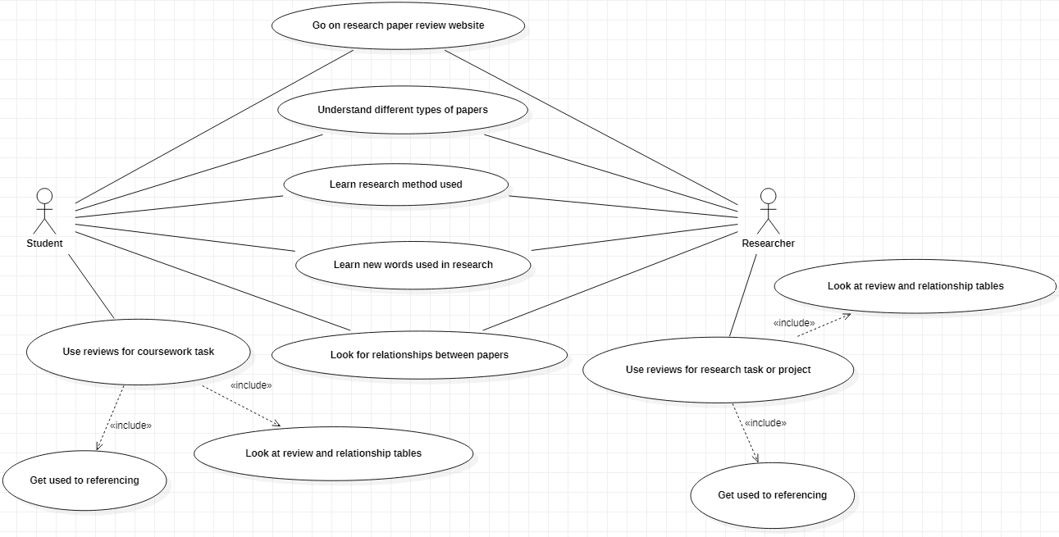 A line joins each actor to the use case in the oval. A line from the student and one from the researcher to the oval. The use case in the oval is “Read reviews of research material” as that is what they are doing. When planning the use of software or a website to read information, there are actors and the system. The actors being outside the system.

#### Sequence Diagram

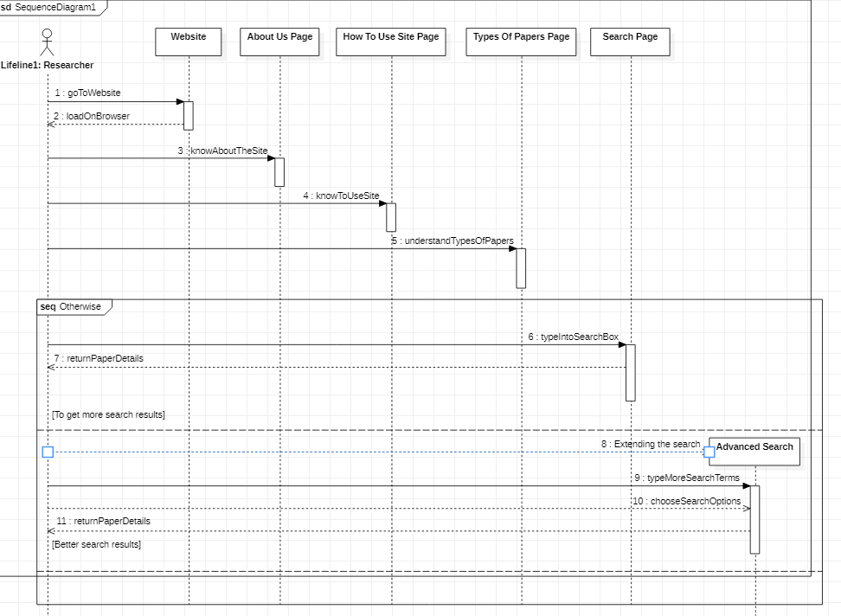This is a simple diagram showing the activities being carried out by the actors and the system in a sequence. It has lines going back and forth starting from the top and going down. It shows the sequence of what the actor does with the system - in this case open the web browser and read the reviews on the website.

#### Class Diagram

This shows the relationship between the classes in the use case in more detail. Anything physical that does tasks in the use case situation can be a class. Let’s have the student, researcher, computer, mobile device, the website itself as the classes. The relationships these classes have with each other are with lines joining them together. These are known as an association. Then there are multiplicities that indicate the type of relationship like one to many or many to one. Each attribute has its type of data for e.g. Boolean. Then we have the operations which are known basically as the methods. Each class is a box divided into two sections – one for the attributes and the other for the operations.

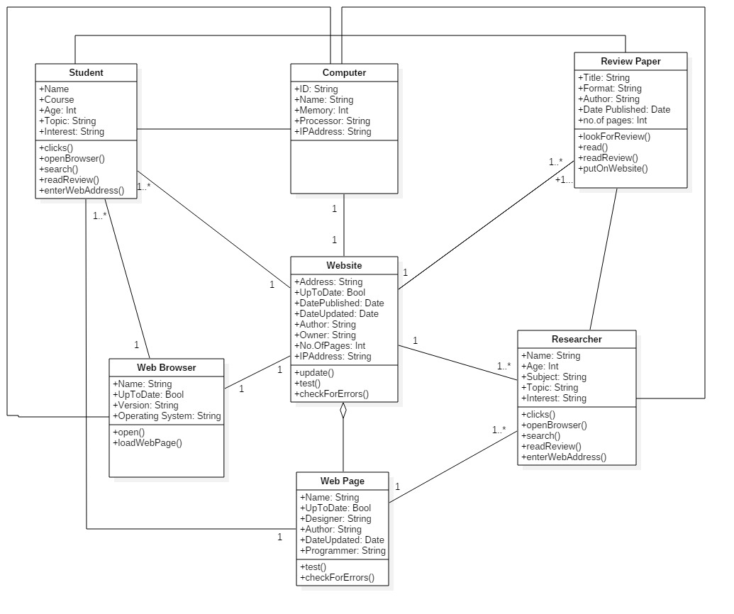

### Qualitative and quantitative approach

There is qualitative and quantitative approach that are needed to be taken. It seems mostly qualitative approach needs to be taken. The topic focuses on facts, theories and practical information to work on rather than measurements of data in numbers. Both approaches may need to be taken at some point in the research.

#### Reasons to do research of qualitative data?

Data to be researched is going to for designing and making the website and running the database the website includes. This is likely to be theories, information about practical work to do rather than data that is being measured in numbers. Qualitative data is used for learning how this website is planned and laid out in a way to attract people to use it. This is likely as theories and practical information. No measurements of data in numbers or figures are needed to do this.

The practical work will have to be learned to make the artifact work the way it is expected to work. This is by researching data that is not given as statistics. It is given as words that give reasons why the website is designed and made to attract users. It is given as words that tell the reader how planned and made to do this. Also to learn and do program coding to run the website and the database it includes. Quantitative data may not need to be researched as much as qualitative data.

#### Reasons to do research of quantitative data?

Quantitative data may need to be researched at a point to find out measured data in numbers or statistics. This could be numbers of students who are likely to use websites that are designed in a certain way. Or the number of people who are more used to websites that have content, buttons, controls, images, colour put on web pages in a certain style. It is necessary to learn this to design the website to get visitors. It seems important to develop the website by reading certain facts and figures. Facts and figures, that are measured, to do with making it. Reading the right facts and figures is important in helping with making the website work well. This data is needed to researched at this point but is not needed to be researched at other points.

# Designing the Website

## Tools to develop the website

Presentation Software – like a presentation processor to design the pages of the site on each slide. Put the layout of each page – how they should look, where the user would go to find what they are looking for. If the user is looking for certain or specific types of information, they want or need, the pages should have ways to other sections or options for the user to choose to get to the information. The presentation file is going to have this on each slide. There will be labels, annotations to briefly explain what goes where on the pages, what the controls and buttons do to find specific info.

Html – Could create it using just this language if that is easier. Brush up on my knowledge of this including html tags, table, links and image with source tags and their attributes. Catch up by going through the notes, books and online tutorials that I have available to look at. This comes under the tool being a text-editor such as Notepad. You write text and edit in HTML and in any other language on it.

CSS – This is just the styling language to style each web page. Written and run together with HTML to style the pages. Each of its tags and attributes are put together with those for HTML in the html file to run the page in the style that has been given. You can also put the code in a separate css file plus make a link to it in the html file.

Javascript – This is the language to program the website. It attracts the user to the website and to even take interest in the website. The code is written and run in this to make the website interactive. Program it to make objects move across the screen…

JSON – This is a Javascript language. It is more advanced for programming the website if the website is going to be used on a mobile device as an application. A web application that is wanted and needed to be developed. JSON (Javascript Object Notation) is a programming language that works with objects in the code…

Website builder – learn how to design and develop the site on web builder WIX.com. Try to understand all the necessary code on the back end of the website. Plus the code to run the back end database with the website. Find out, as much as possible, how to design the pages on this. for our Group Research Project last year a website was designed on WIX.com. It could be necessary to find out how it was built such as creating the account, designing each page. Plus working on the code to make the website work and the database on the backend.

Notepad – this is the text-editor. Any code is written on it to make a website work. Code or codes in a certain language to make it work. Code that is written on the text editor are saved as files for each page of the website. Can be saved as many file formats by giving the file extensions to the file name like .html, .js,.css.

Star UML – The software that is used to draw my UML diagrams to do with the use case of the website. The diagrams annotated, filled in with text. Also with lines and labels to show the relationships depending on what is being done in the use case of the website. There are many different shapes on the software to choose as well as lines and text.

Zotero API – Since the website includes a database that stores data about the research papers there is programming known as Zotero API. To program the data to be stored in the database. The database is not the same as a database on the back end that is run by PHP programming language. It is run on the browser. There is the Zotero code to run it which needs to be learned. It is practised and tested differently to PHP programming language to program a database on the back end of a website.

## Planning

### Target Audience

The website is likely to be aimed at young people aged between 18 and 60. People in this age range are likely to be students at university. Plus those who are ready to do research. When you become a student you make progress in life with the course you are doing. You have gained knowledge and experience from the courses you did at college and the life there. When you start doing a course as a student you have made progress in life with an interest in the course plus the point of doing it. You could soon decide to research information on a topic of the course you find interesting. These are reasons for the website to be aimed at students who are 18 to 60 years old.

Researchers at university level know more about researching than students. They have more advanced topics to look for information on. Topics with more detail of information that students do not know. They know how to do more research than students and know more methods of doing research. This does not stop the website being aimed at only at students rather than researchers. It is rather their level of knowledge, how mature and well educated they are. The interests they have taken in in different topics as time has gone as well as knowledge. This is the reason to aim the website at them even if they aged between 20 to 60 years.

### Purpose and Need for The Website

When designing and making this website it is important to make sure:

* It is laid out in a way and has information that people will actually use
* There are no bits of content missing that users want or need on the website

This artifact that is being created is expected to be new. Not like one that already exists. It can be an improvement of a similar one that artifact exists. There are images of websites that review research papers but not clearly. These are just tables of examples of reviews. These are not clear enough for students and researchers to stay on track of their progress with reading. Not enough information to study to see which papers you have been reading are worth it and which papers should be read next. It seems there is a need for the website at this stage.

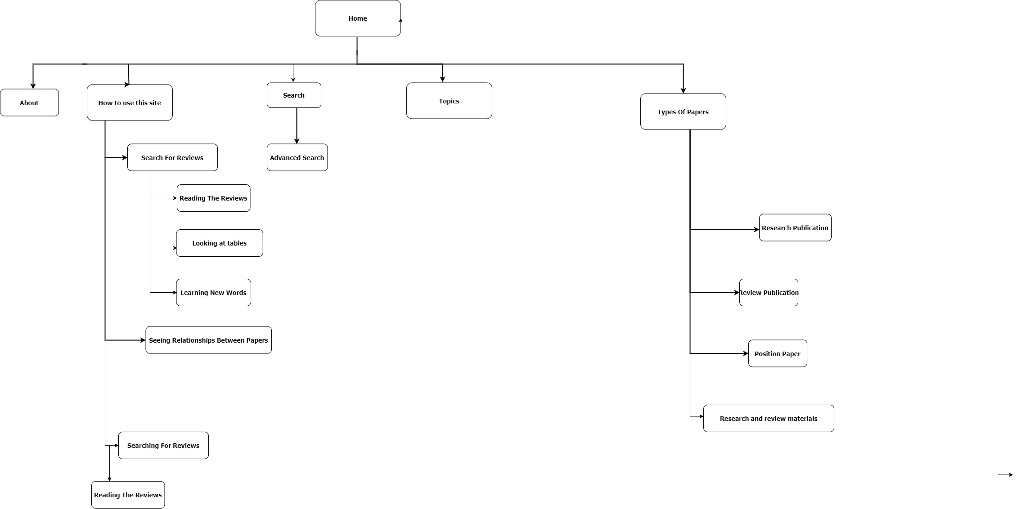

Fig1. Sitemap

# The Website

The artifact being created here is a website. Designed by coming up with a suitable target audience and a suitable layout of each page of the website. Also the right purpose and need to make this artefact. Developed and tested with technologies known as web. Technologies are anything to do with making the website. These are known as html, Javascript and CSS coding language. Also to program the artefact.

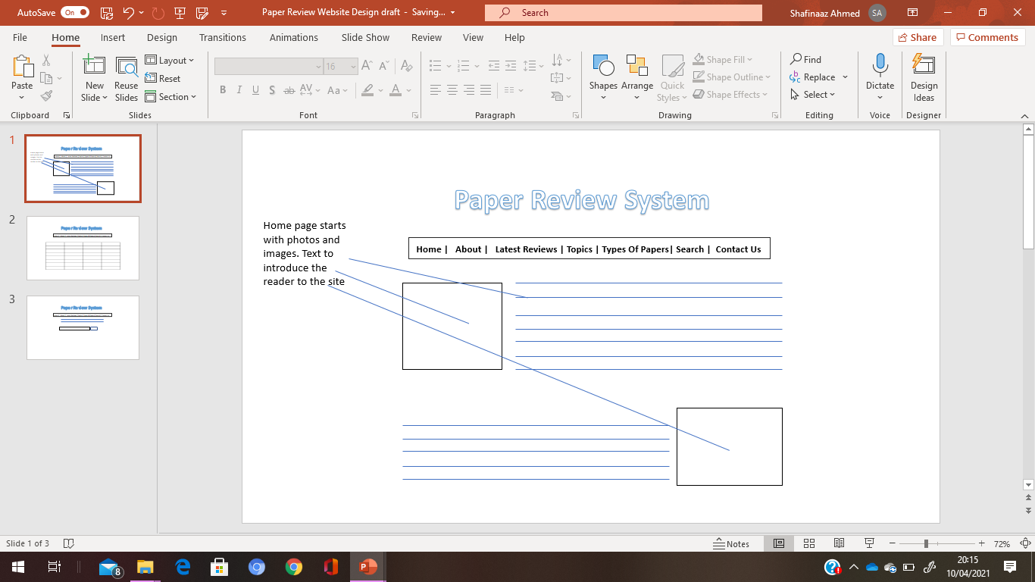

The website simply is made of several pages of useful information. Information of many different types of research papers. Research papers that are recent or have recently been read. Also of review papers that are made of a review of another paper. This is arranged by having paragraphs of text, tables, drop down combo boxes, images, photos and links to other pages. Tables of details of each research and review paper for the user to read through.

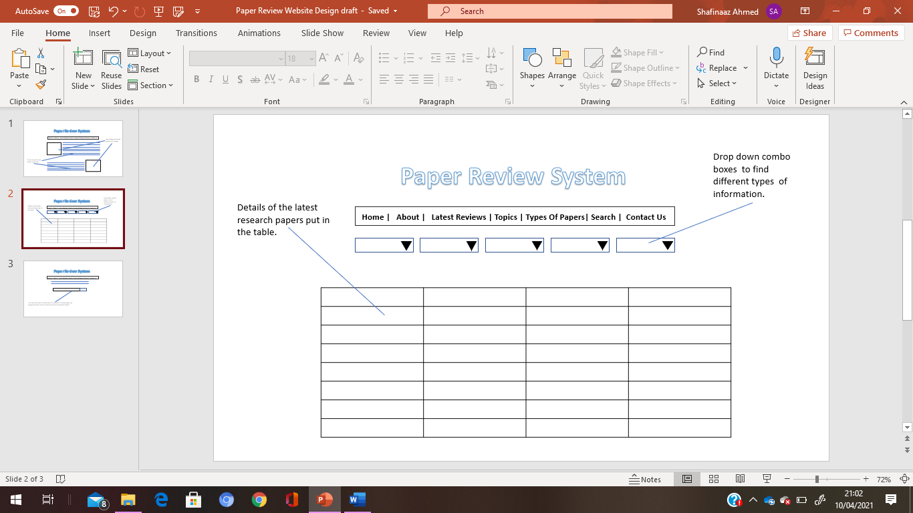

The key features of this artifact are tables, buttons, moving images and shapes, radio buttons, text boxes, for searching, and the database. Information divided in a table of each research and review material. Divided in a way that the user can understand what they are reading to keep track of their progress. There is the database that stores data about the research and review materials. This is by getting to the Zotero code that runs the database. This works with the web browser.

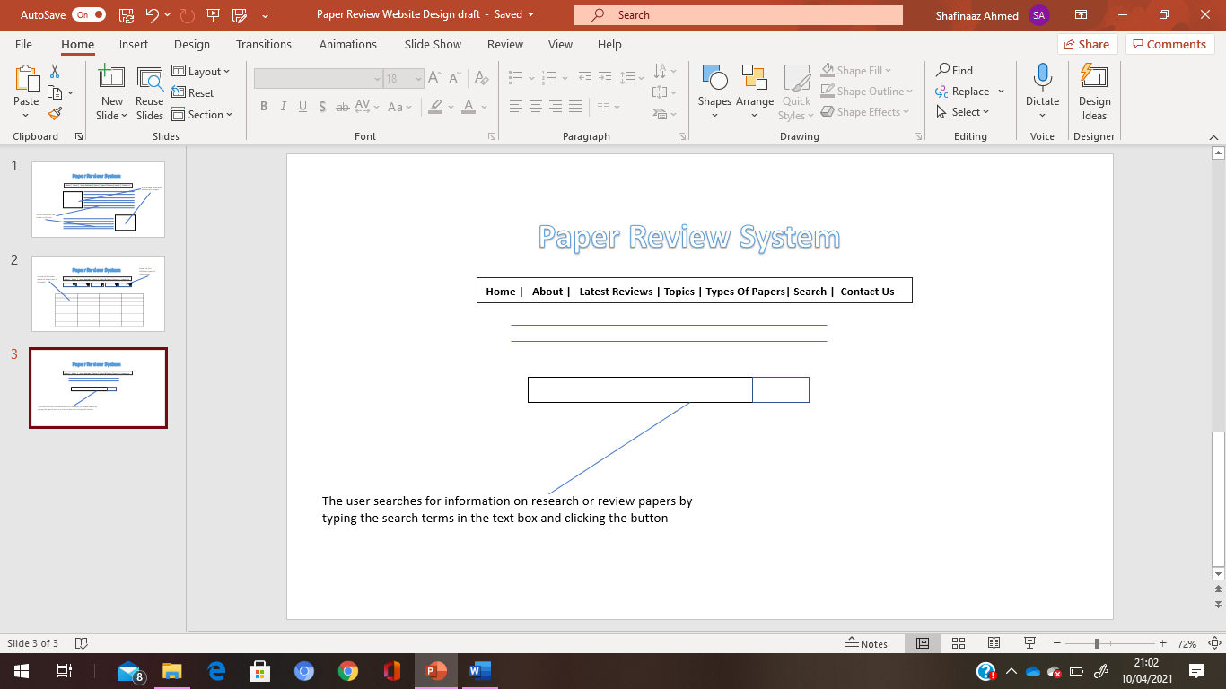

Moving images and shapes are the interactivity on the pages. These are there to attract the user to the website and make them want to keep looking at it for information. Images, drop down menus and text boxes are to be put on the pages to keep the user attracted to the website. Text boxes to search for details of research or review papers are important. This helps the user stay on the site until they find the reviews or useful information about the papers.

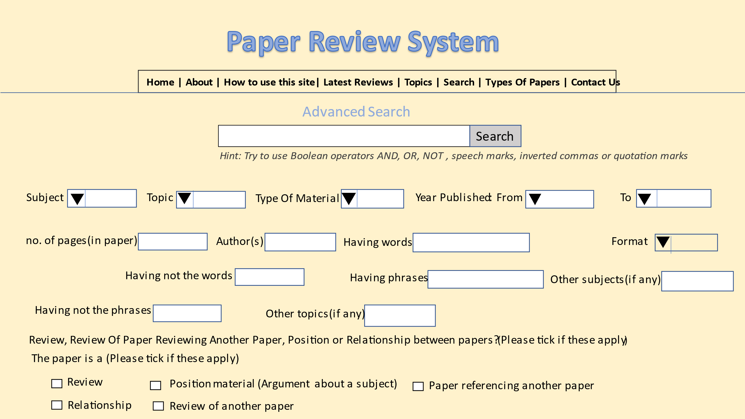

Having added colour and added controls to the advanced search page to give it a fair look. This pages help the student, researcher to find the specific information they are looking for. Like the filters when searching for an academic on Google Scholar or Summon in the UWL library website. The controls are to choose options from the drop down boxes. It is worth having this control. Most textboxes are here which is easier for the user to advance search by typing in many terms.

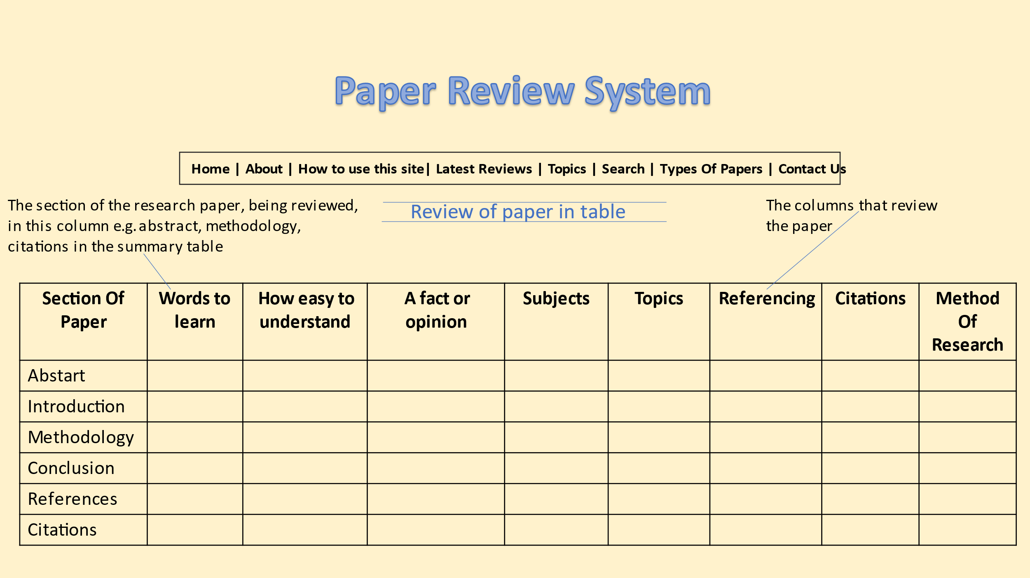The design of the review as a brief summary in a table. To summarize the details of the paper in the table there should be the first column on the left that has each section of the paper. The review of it is in the rest of the columns. The details under each column which are in each section of the paper.

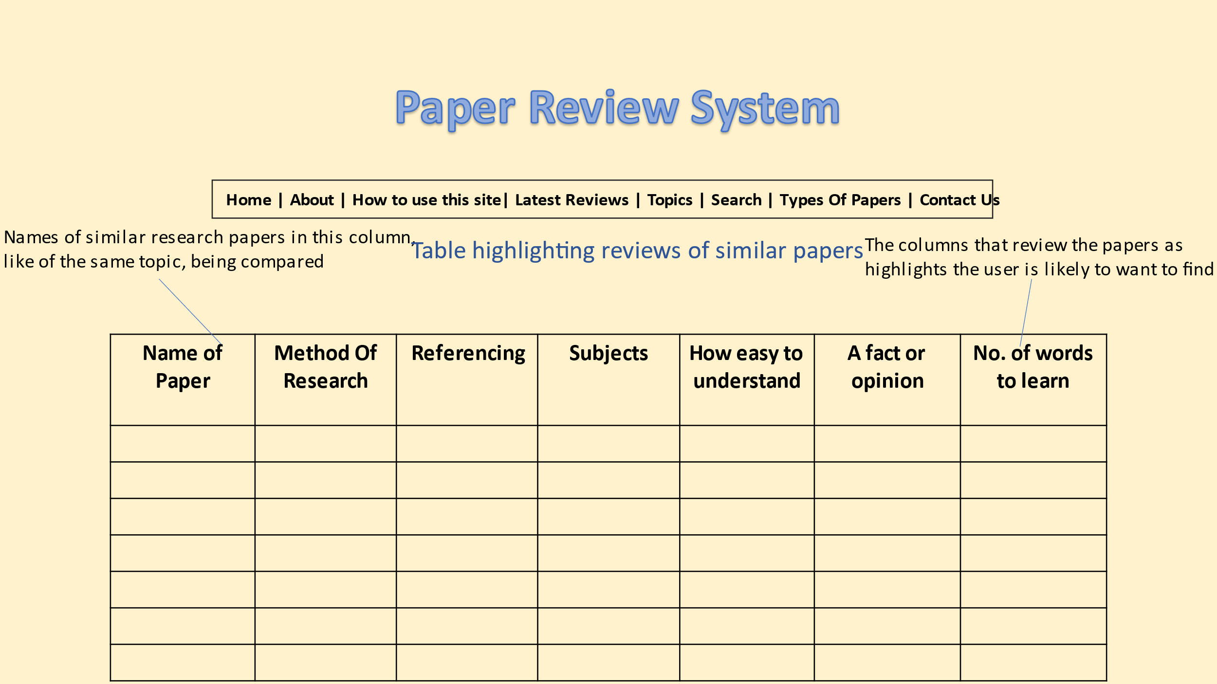

This design is the table that has brief highlights of papers in common with each other. Those that are of a similar subjects, topics.

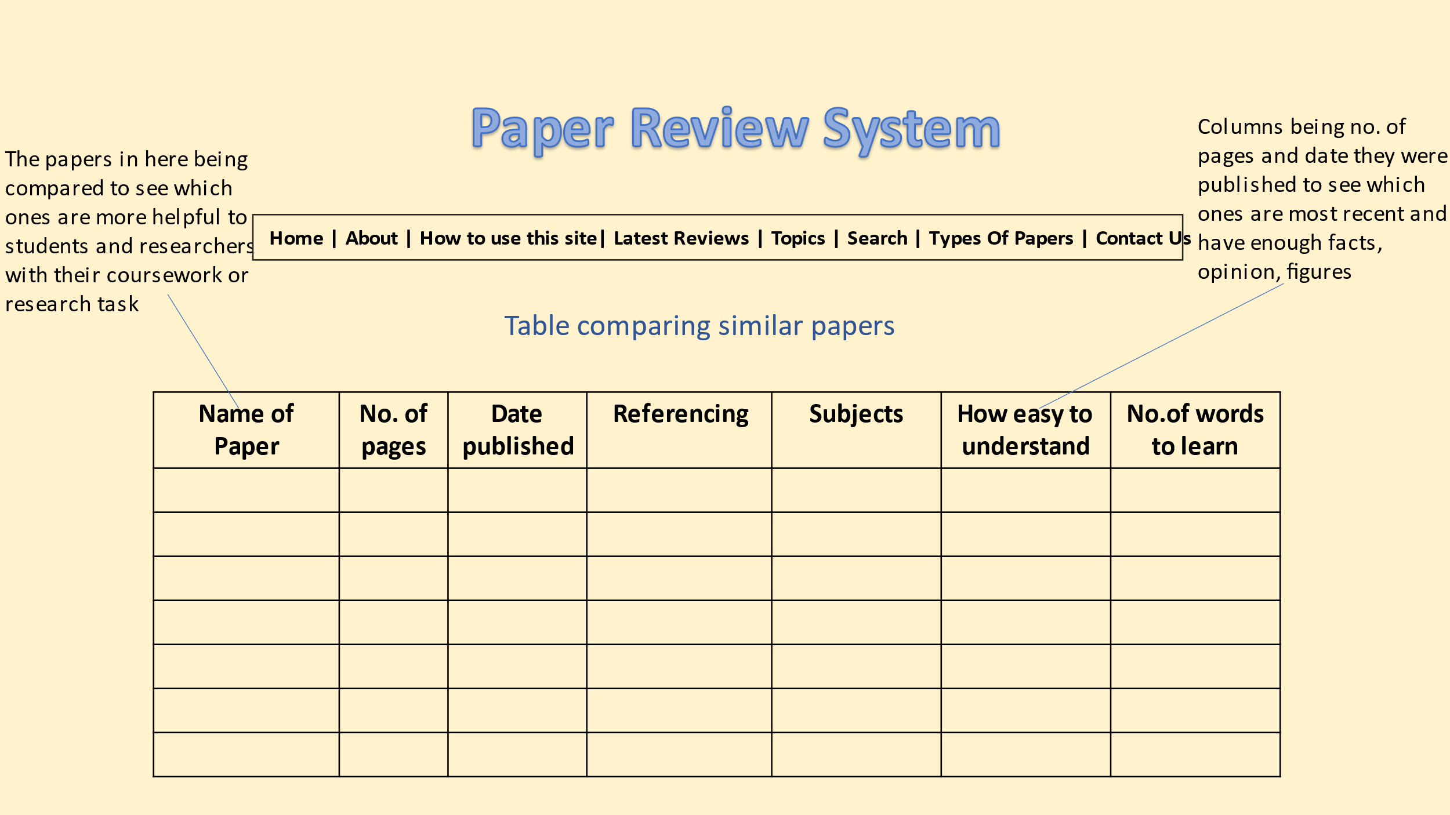

The table having details of papers making references of or reviewing another paper.

### Developing Stage

The html to make the website begins with the tags, attributes, source src tags for linking the images in the images tag, table tags and the a href tags for the links to other pages or websites. Each web page created in this language is saved as a html file(.html file extension).

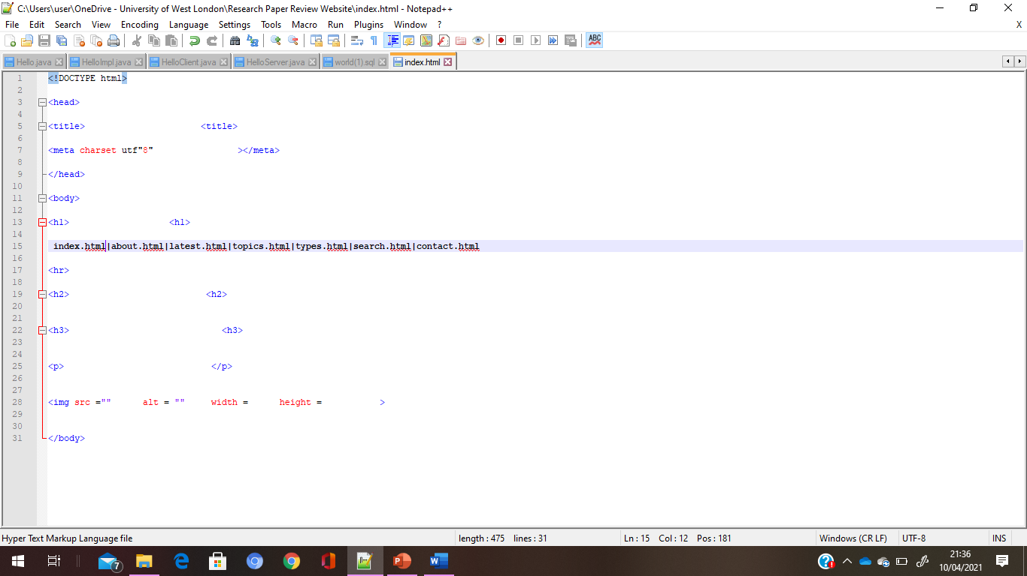

The first page is known as index.html. This is because it is the first page of the website that introduces each page of the site like an index. It has each page to go to by clicking on their names. It has the image tag with the src attribute. This attribute having the path name of image i.e. which folder the image is stored in. This is needed to put the image on the web page. This tag then has the width and height attributes to put the image in the right size on the page. A hr tag is put below the links to the pages of the website. This is the horizontal rule. Between the heading, title and page names at the top and the content on the rest of the page is the horizontal rule.

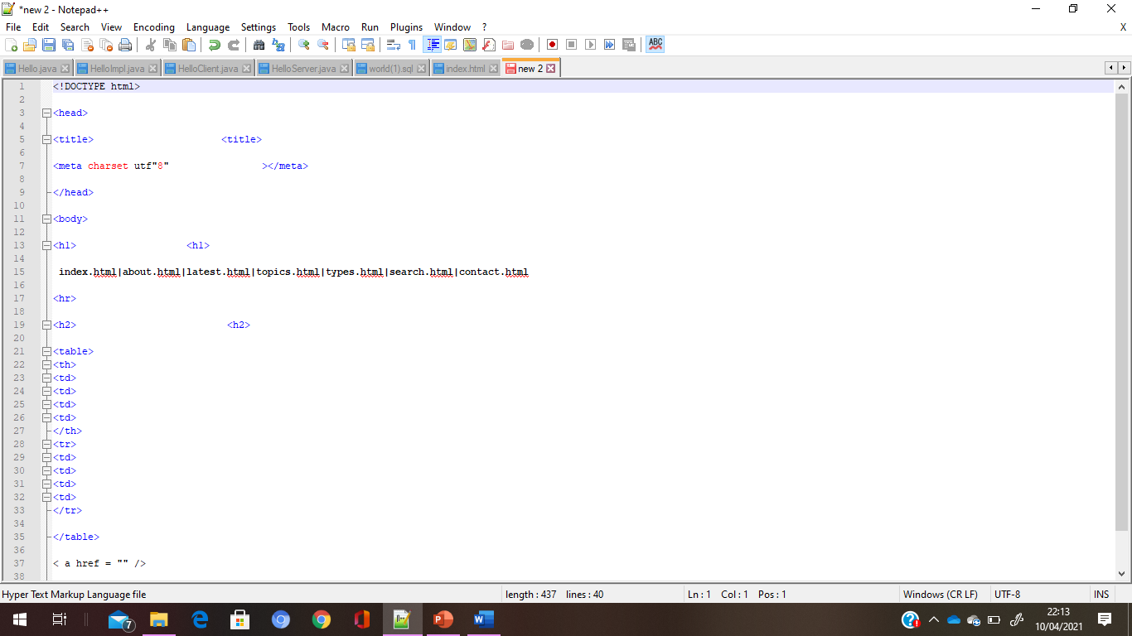

Meta tags are handy for the website to be found as the search results when searching for it on the engine. The tags to create the table are put in order starting from the table heading to the rows. The heading and rows each have their table data tags to put the data into the table. These are all put within the table opening and closing tags. The link to another website starts with the a href tag. This equals the address of the website that is being linked to.

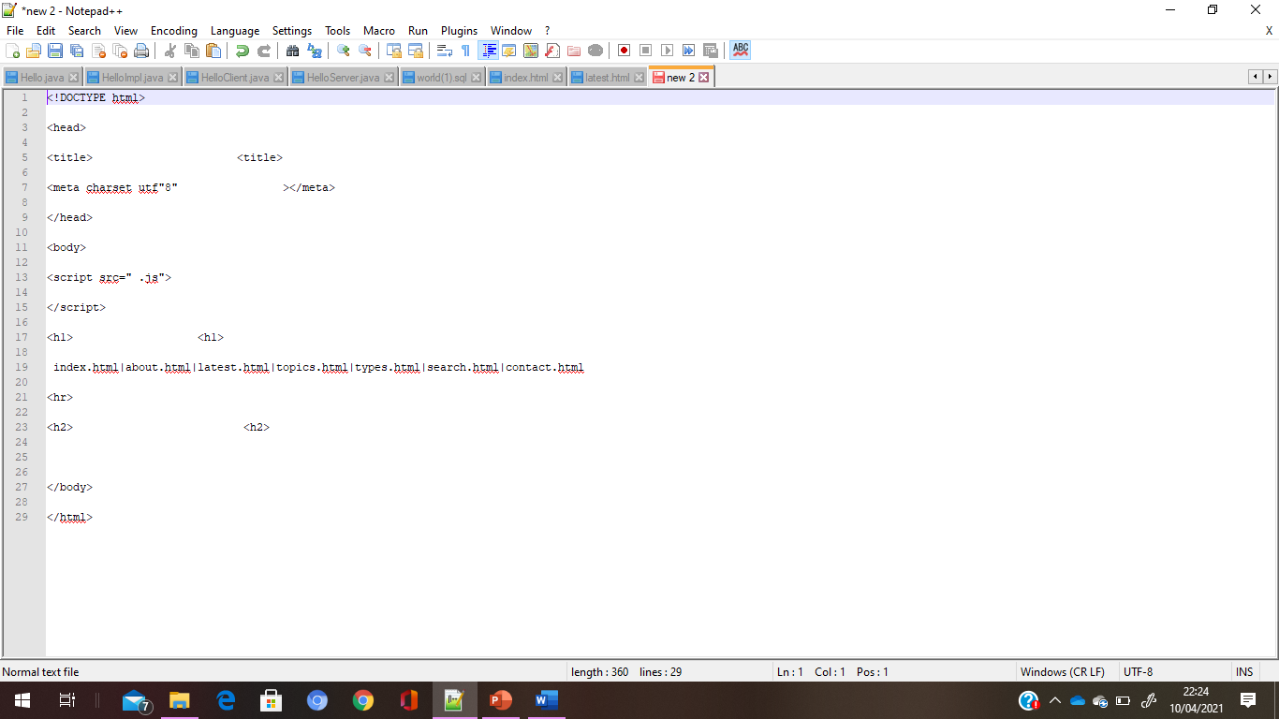

Putting the text box with its search button is done by code written and run in Javascript language. This language written to program the web pages to different tasks. Tasks which the user wants or needs them to do. Just below the opening body tag is the script tag which links the html page to the Javascript file. The Javascript file is a separate notepad file that has code written in the language to program the website for different tasks to be done on the website. The tag is a script tag because the language is Javascript. It has the src attribute linking the html file to the Javascript file. This file ends with the extension .js.

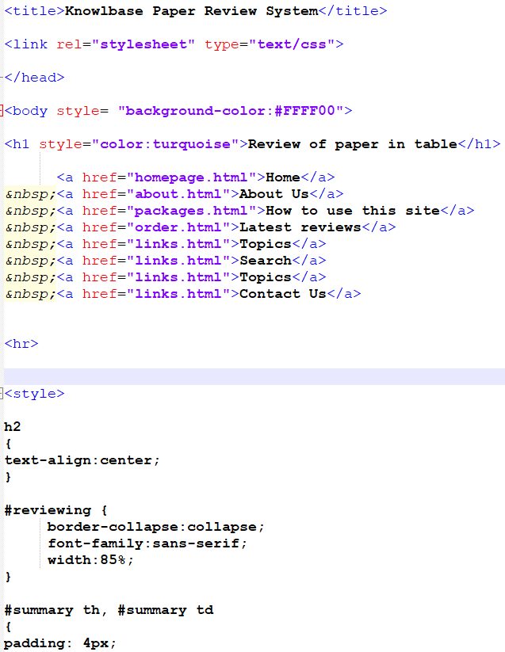

On the text editor Notepad plus plus the page that reviews a paper in the table is created. It is created in HTML and CSS. Beginning with a link to the cascading style sheet and the anchors to make the navigation at the top of the page. Each of them makes a link to the other pages. The styles not made for the page in the separate style sheet are on this HTML page under the style tag. These are the ID selectors and elements.

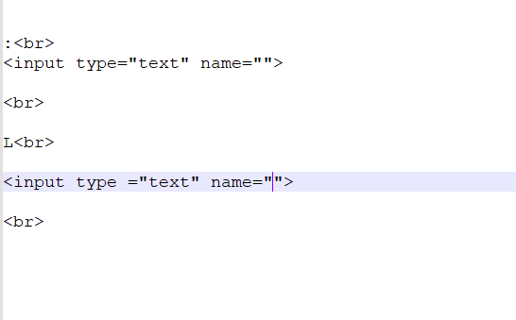

The controls on the Search page are made by these lines.

explain the actual artifact, screenshots, key features, the coding etc

# Discussions

Discuss about the results of my research. If they answer the research questions. If they do, discuss how they answer the questions?

# References

### **My referencesite this article**

Rosen, D.E. and Purinton, E. (2004) ‘Website design: Viewing the web as a cognitive landscape’, *Journal Of Business Research*, 57(7), pp.787-794.

Rothenfluh F. *et al.* (2016) ‘Consumer Decision-Making Based on Review Websites: Are There Differences Between Choosing a Hotel and Choosing a Physician?’, *Journal Of Medical Internet Research*, 18(6), pp. e129-e129. doi: [10.2196/jmir.5580](https://doi.org/10.2196/jmir.5580)

IntelligentHQ (2021), ‘Making Websites More Accessible And Easy To Use’, *ProQuest,* 12 Jan. Available at: http://ezproxy.uwl.ac.uk/login?url=https://www-proquest-com.ezproxy.uwl.ac.uk/blogs-podcasts-websites/making-websites-more-accessible-easy-use/docview/2476835092/se-2?accountid=14769

Adams, S.A. (2011) ‘Sourcing the crowd for health services improvement: The reflexive patient and “share-your-experience” websites’, *Social science & medicine (1982)*, 72(7), pp. 1069-1076. doi:[10.1016/j.socscimed.2011.02.001](https://doi-org.ezproxy.uwl.ac.uk/10.1016/j.socscimed.2011.02.001)

Dunne, S. *et al*. (2013) ‘A Method for the Design and Development of Medical or Health Care Information Websites to Optimize Search Engine Results Page Rankings on Google’, *Journal of medical Internet research*, 15(8), pp. e183-e183.doi:[10.2196/jmir.2632](https://doi.org/10.2196/jmir.2632)

SUNDAY, A.A. (2021) ‘Use of Twitter Technology in Educational Learning.’ *TOJET: The Turkish Online Journal of Educational Technology*, 20(2).

De Leo, G et al. (2006) ‘Websites most frequently used by physician for gathering medical information.’, *AMIA .Annual Symposium proceedings,* 2006 pp.902-902.

Sari, A.D *et al.* (2015) ‘Usability analysis of laboratory website design to improve learning process’, *Procedia Manufacturing*, 3, pp.5504-5511. doi: [10.1016/j.promfg.2015.07.703](https://doi.org/10.1016/j.promfg.2015.07.703)

Rezaeean, A *et al*. (2012) ‘The importance of Website Innovation on Students' Satisfaction of University Websites’, *World Applied Sciences Journal*, 18(8), pp.1023-1029. doi: 10.5829/idosi.wasj.2012.18.08.1643

Garett, Renee *et al*. (2016)‘A Literature Review: Website Design and User Engagement,’ *Online Journal of Communication and Media Technologies*, 6(3), pp.1-14. Available at: <https://www.ncbi.nlm.nih.gov/pmc/articles/PMC4974011/> (Accessed: 5 July 2021)

Martinez, D *et al*. (2019) ‘*Website Modernization: Making Your Website Work for You.’* Available at: <https://researchexchange.iaao.org/conference/IAAO2019/schedule/19/> (Accessed: 5 July 2021)

Swartz, M. (2010) ‘Making a website jobseeker-friendly’, *Canadian HR Reporter*, 23(8), [Online], pp.22. Available at: <http://ezproxy.uwl.ac.uk/login?url=https://www-proquest-com.ezproxy.uwl.ac.uk/trade-journals/making-website-jobseeker-friendly/docview/220818676/se-2?accountid=14769> (Accessed: 5 July 2021).

Grantham, J *et al.* (2012) ‘Website accessibility: an Australian view’, In *Proceedings of The Thirteenth Australasian User Interface Conference*, 126 (pp. 21-28).

Asadi, A. & Montazer, G.H. (2014) ‘A Model for the Design of Virtual University’s Website Using Multicriteria Decision Making’, *Nashrīyah-i ʻIlmī pizhūhishī-i fannāvarī-i āmūzish*, 8(3), pp. 159-174.doi: <https://doi.org/10.22061/tej.2014.93>

Martin-Kerry, J.M et al. (2019) ‘Supporting children and young people when making decisions about joining clinical trials: qualitative study to inform multimedia website development’, *BMJ Open*, 9(1), pp. e023984-e023984 doi:[10.1136/bmjopen-2018-023984](https://dx.doi.org/10.1136%2Fbmjopen-2018-023984)

Zhao, M et al. (2021) ‘Study on hotel selection method based on integrating online ratings and reviews from multi-websites’, *Information sciences*, 572, pp. 460-481. doi: [https://doi.org/10.1016/j.ins.2021.05.042](https://doi-org.ezproxy.uwl.ac.uk/10.1016/j.ins.2021.05.042)

Yang, L et al. (2010) ‘Interventions to promote cycling: systematic review’, *BMJ*, 341(7778), pp.67;46;48;1164;a1655;CD003180;354;1930;179;1034;50;73;519;CD005575;281;1050;341;266;1204;1621;201;763;103;324;645;8;9;703;407;41;-870. doi:<https://doi.org/10.1136/bmj.c5293>

Hone, D.W *et al*. (2011) ‘Running a Question-and-Answer Website for Science Education: First-Hand Experiences’, *Evolution: Education and Outreach*, 4(1), pp.153-157. doi: https://doi.org/10.1007/s12052-011-0318-5

Lee, Y. & Kozar, K.A (2012) ‘DESIGNINGWEBSITES AND COMPOSING MUSIC: IDENTIFYING USABILITY CONSTRUCTS AND THEIR NOMOLOGICAL NETWORKS’, *Journal of Electronic Commerce Research*, 13(4), pp. 320-344.

Anders, S.B. (2013) ‘Website of the Month: NAPLIA’, *The CPA Journal(1975)*, 83(10), p.72.

Newstex (2018) ‘Abrition: 5 Things to Keep In Mind While Designing a Website’, *ProQuest*, 16 December. Available at: https://www-proquest-com.ezproxy.uwl.ac.uk/docview/2156791416/citation/E65F8FA91EB74BC6PQ/1?accountid=14769

Finlay, d. (2012) ‘Keep it simple when designing a website’, *Mortgage Strategy*, [Online], pp. 16. Available at: <http://ezproxy.uwl.ac.uk/login?url=https://www-proquest-com.ezproxy.uwl.ac.uk/trade-journals/keep-simple-when-designing-website/docview/1001132055/se-2?accountid=14769> (Accessed: 8 July 2021)

Rozic‐Hristovski, A et al. (1999) ‘Developing a medical library website at the University of Ljubljana, Slovenia’, [*Program: Electronic Library and Information Systems*](https://www.emerald.com/insight/publication/issn/0033-0337), 33(4), pp.313-325. Doi: <https://doi.org/10.1108/EUM0000000006921>

Bouvier, D.J. (1995) ‘The state of HTML’, *ACM SIGICE Bulletin*, 21(2), pp.8-13.doi: [https://doi.org/10.1145/220230.220236](https://doi-org.ezproxy.uwl.ac.uk/10.1145/220230.220236)

Bakhtiari, M. (2012) ‘SU‐E‐J‐114: Web‐Browser Medical Physics Applications Using HTML5 and JavaScript’, *American Association of Physicists in Medicine.* United States, pp. 3678.

Keith, J. and Scripting, D.O.M.(2005) ‘Web Design with JavaScript and the Document Object Model’, *Friends of ED Publishing*, pp. 5.doi: https://doi.org/10.1007/978-1-4302-0062-8

Chen, H.H *et al*. (2000) ‘Mining tables from large scale html texts’, *COLING 2000 Volume 1: The 18th International Conference on Computational Linguistics*

Mesbah, A. & Mirshokraie, S. (2012) ‘Automated analysis of CSS rules to support style maintenance’, *IEEE Press*, pp. 408.doi: [10.1109/ICSE.2012.6227174](https://doi.org/10.1109/ICSE.2012.6227174)

Jacobs, S *et al.* (1996) ‘Filling HTML forms simultaneously: CoWeb—architecture and functionality’, *Computer Networks and ISDN Systems*, 28(7-11), pp.1385-1395.doi: <https://doi.org/10.1016/0169-7552(96)00054-2>

Cutler, M., Shih, Y. and Meng, W., 1997, December. Using the Structure of HTML Documents to Improve Retrieval. In USENIX Symposium on Internet Technologies and Systems (pp. 241-252).

Yadav, P. and Barwal, P.N. (2014) ‘Designing responsive websites using HTML and CSS’, *International Journal of Scientific & Technology Research*, 3(11), pp.152-155.

Tilkov, S. & Vinoski, S. (2010) ‘Node.js: Using JavaScript to Build High-Performance Network Programs’, *IEEE Internet Computing*, 14(6), pp. 80-83.

Embley, D.W. et al. (2005) ‘Automating the extraction of data from HTML tables with unknown structure’, *Data & Knowledge Engineering*, 54(1), pp.3-28.

Garcia-Plaza, A.P et al. (2017) ‘Using Fuzzy Logic to Leverage HTML Markup for Web Page Representation’, *IEEE Transactions On Fuzzy Systems*, 25(4), pp. 919-933.doi: [10.1109/TFUZZ.2016.2586971](https://doi.org/10.1109/TFUZZ.2016.2586971)

Morrison, G.(2019) ‘Explorations in Bibliography: Zotero Goes Public’, *Atla Summary of Proceedings*, pp.218-221.doi: <https://0-doi-org.librarycatalog.vts.edu/10.31046/proceedings.2019.1613>

Pearlman, A. (2019) *Bringing Zotero to iOS*, Georgetown University. Available at: <https://repository.library.georgetown.edu/bitstream/handle/10822/1056622/Pearlman_Bringing%20Zotero%20to%20iOS.pdf?sequence=1&isAllowed=y> (Accessed: 15 July 2021).

(2009) ‘USEFUL WEBSITES: Zotero puts a new spin on citation management, and more’, *Disease models & mechanisms*, 2(1-2), pp. 8-8. doi: [10.1242/dmm.002337](https://dx.doi.org/10.1242%2Fdmm.002337)

Ahmed, K.K.M. & Al Dhubaib, B.E. 2011, ‘Zotero: A bibliographic assistant to researcher’, *Journal Of Pharmacology & Pharmacotherapeutics*, 2(4), pp. 303-305.doi: [10.4103/0976-500X.85940](https://dx.doi.org/10.4103%2F0976-500X.85940)

Cohen, D.J.(2008) ‘Creating scholarly tools and resources for the digital ecosystem: Building connections in the Zotero project’, First Monday,13(8). Available at: <https://journals.uic.edu/ojs/index.php/fm/article/download/2233/2017> (Accessed:15 July 2021)

Vanhecke, T.E.(2008) ‘Zotero’, *Journal of the Medical Library Association*, 96(3), pp. 275-276. doi: [10.3163/1536-5050.96.3.022](https://dx.doi.org/10.3163%2F1536-5050.96.3.022)

# Appendix